

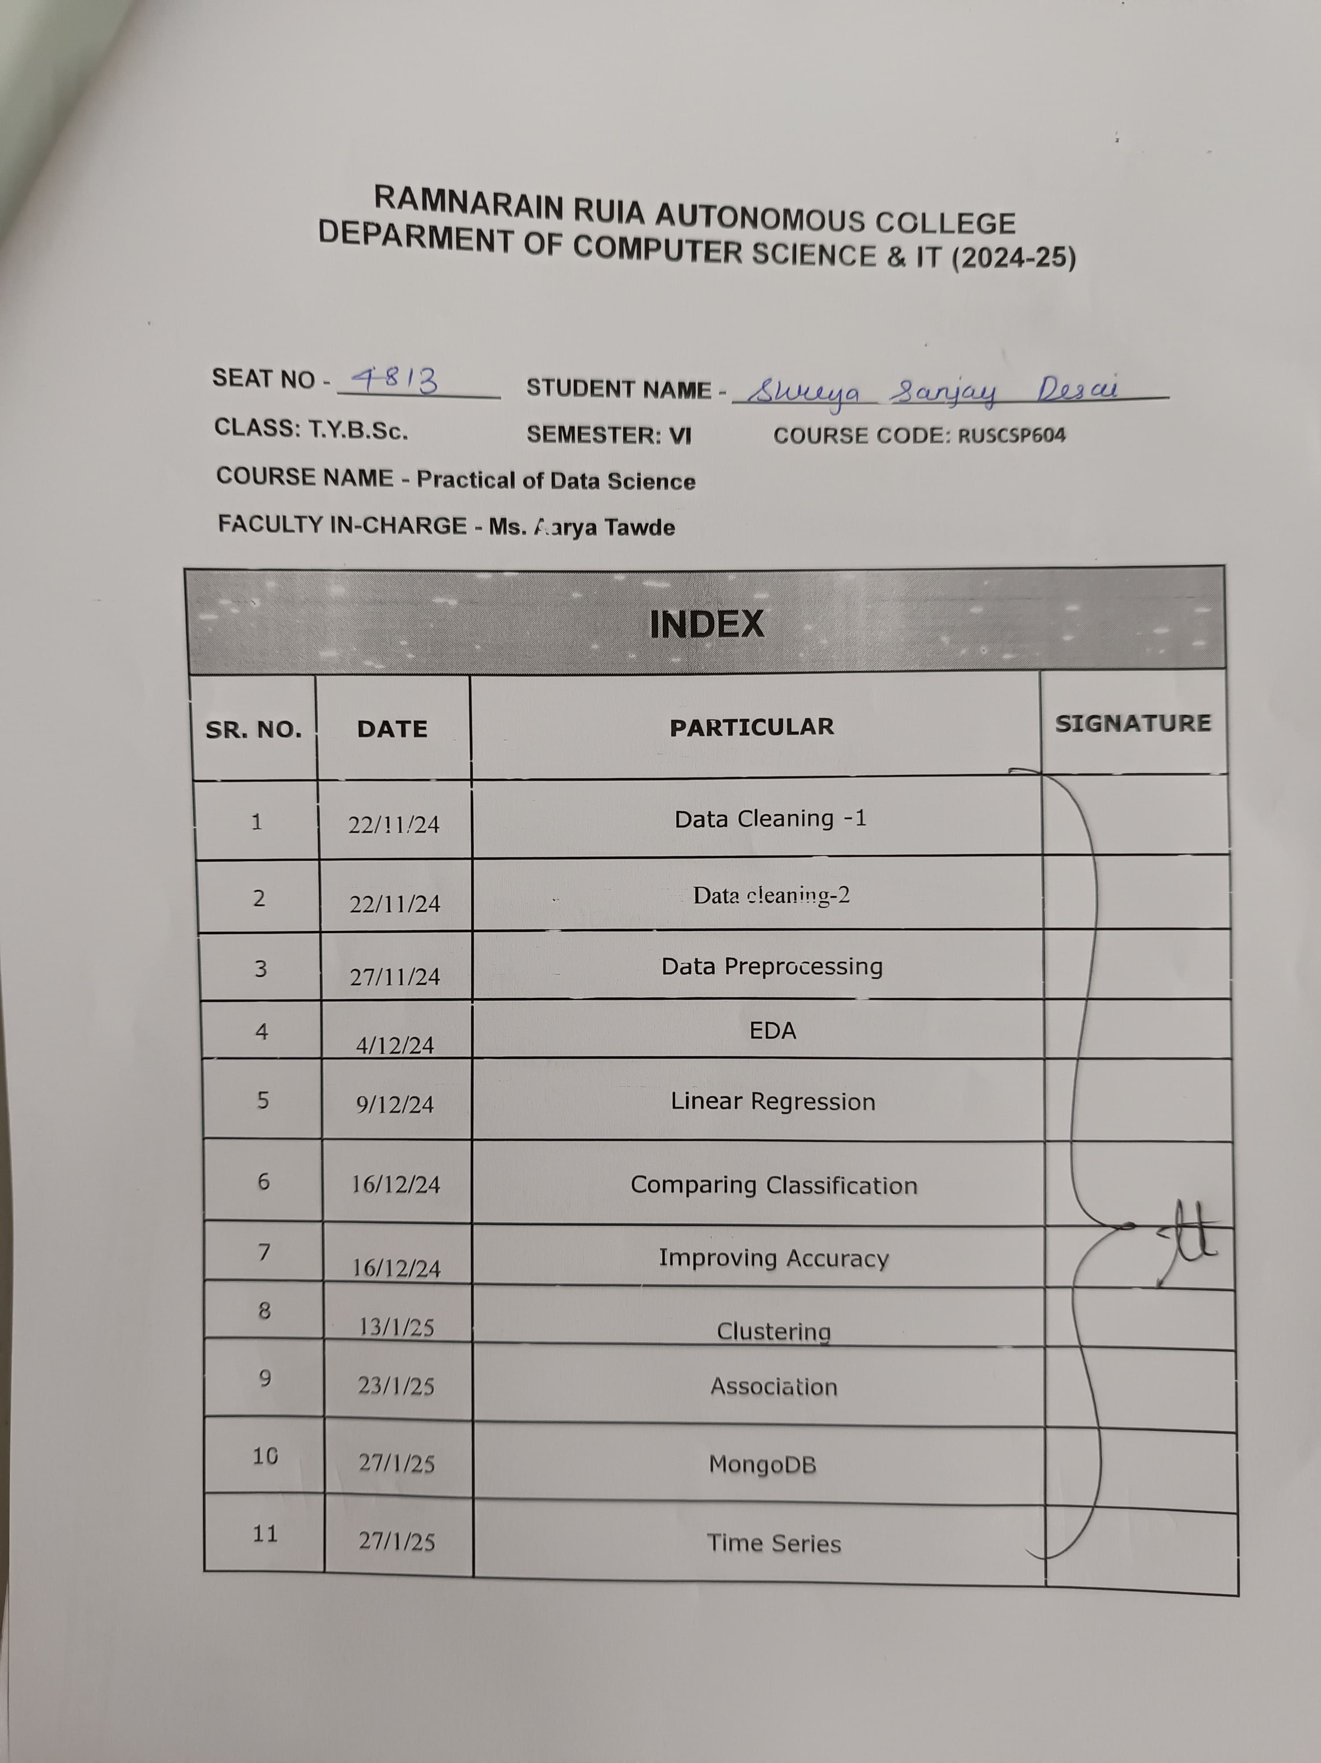

**Practical 1**

**AIM : Data Cleaning – 1**

**Data set :**

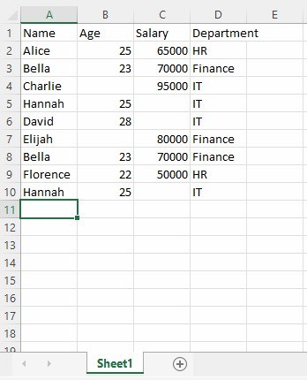

**Title : Missing Values Description :**

Missing Data can occur when no information is provided for one or more items or for a whole unit. Missing Data is a very big problem in a real-life scenarios. Missing Data can also refer to as NA(Not Available) values in pandas. In DataFrame sometimes many datasets simply arrive with missing data, either because it exists and was not collected or it never existed.

**Code :**

import pandas as pd # Load the dataset df = pd.read_csv("Sheet1.csv")

# Display the first few rows to understand the structure of the data print("sheet1.csv \n",df.head())

# Get the shape (number of rows and columns) of the dataframe print("\n(row,column) : ",df.shape)

# Check for null (missing) values in the dataframe print("\n checking for missing value : \n",df.isnull()) # Get the sum of null values in each column

print("\n number of null values in every column : \n",df.isnull().sum())

# Get the total number of null values in the entire dataframe print("\n total number of null values in the entire excel sheet :",df.isnull().sum().sum())

# Filling null values with mean value df3 = df.fillna(value=df['Age'].mean())

print("\n filling NaN value in Age column with mean of that column : \n",df3)

df4 = df.fillna(value=df['Salary'].mean()) print("\n filling NaN value in Salary column with mean of that column : \n",df4)

**Explanation of Code:**

**Step 1: Load and Inspect the Data**

* **pd.read_csv("Sheet1.csv")**: Loads the CSV file into a Pandas DataFrame.
* **df.head()**: Displays the first few rows of the data to understand its structure.
* **df.shape**: Provides the number of rows and columns in the DataFrame.

**Step 2: Identify Missing Values**

* **df.isnull()**: Checks each cell in the DataFrame for missing (null/NaN) values. Returns a DataFrame of Boolean values (True if a value is missing, False otherwise).
* **df.isnull().sum()**: Sums the True values for each column, giving the count of missing values in each column.
* **df.isnull().sum().sum()**: Computes the total number of missing values across the entire DataFrame.

**Step 3: Fill Missing Values with Mean**

* **df.fillna(value=df['Age'].mean())**:
  + Fills missing values (NaN) in the Age column with the mean of the Age column.
  + Other columns remain unchanged.
* **df.fillna(value=df['Salary'].mean())**:
  + Fills missing values in the Salary column with the mean of the Salary column.

**Explanation of Parameters:**

1. **fillna(value=...)**:
   * **value**: Specifies what to replace missing values with. Here, it's the mean of a specific column.
2. **isnull()**:
   * Detects missing values (NaN) in the DataFrame.
3. **sum()**:
   * Computes the sum of values along an axis. Here, it sums True (1) values for missing data.

**Output :**

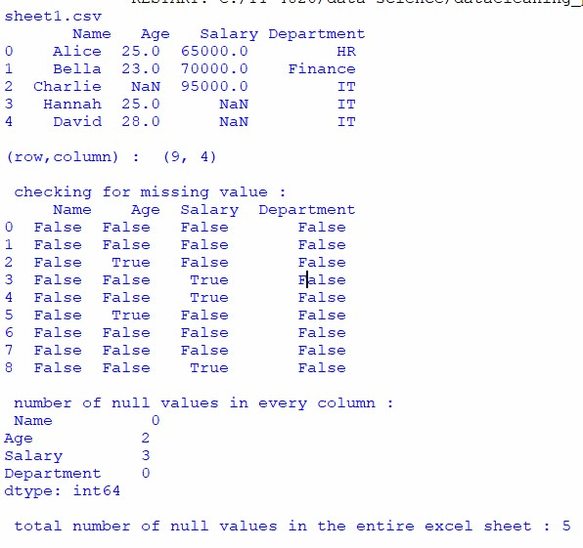

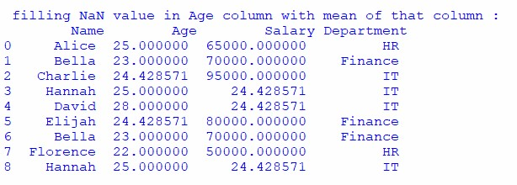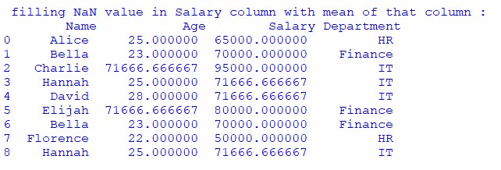

**Output Explanation:**

1. **First Few Rows (df.head())**: Displays a preview of the dataset to understand its structure.
2. **Shape (df.shape)**: Indicates the number of rows and columns in the DataFrame.
3. **Null Value Check (df.isnull())**: Shows which cells have missing data (True for missing, False otherwise).
4. **Null Value Count (df.isnull().sum())**: Lists the number of missing values in each column.
5. **Total Null Values (df.isnull().sum().sum())**: Displays the total count of missing values in the entire DataFrame.
6. **Filling Null Values (df.fillna(...))**: Replaces NaN values in specific columns with their respective mean values.

**Title : Removing duplicates**

**Description :**

Removing duplicate rows is a key step in data cleaning to ensure the dataset's quality, reliability, and efficiency during analysis. Duplicates can occur due to data entry errors, merging multiple datasets, or scraping data from external sources.

**Code :**

**Remove Rows That Are Entirely Duplicated the Most** import pandas as pd # Step 1: Load your CSV file

file_path = 'Sheet1.csv' # Replace with your actual file path df = pd.read_csv(file_path)

# Step 2: Remove duplicate rows, keeping only one of each duplicate df_cleaned = df.drop_duplicates()

# Step 3: Save the cleaned data

cleaned_file_path = 'cleaned1.csv' # Replace with your desired output file name

df_cleaned.to_csv(cleaned_file_path, index=False)

print("Duplicates removed. Cleaned data saved to:", cleaned_file_path)

**Explanation of Code:**

**Step 1: pd.read_csv(file_path)**

* **Purpose**: Loads the dataset from a CSV file into a Pandas DataFrame.
* **Parameter**: o file_path: Path to the CSV file (e.g., 'Sheet1.csv').

**Step 2: df.drop_duplicates()**

* **Purpose**: Removes rows that are identical (fully duplicated across all columns).
* **Parameters**:
  + **Default behavior**: Removes duplicates while keeping the first occurrence of each unique row.
  + keep:
    - "first" (default): Keeps the first occurrence of each duplicate row.
    - "last": Keeps the last occurrence of each duplicate row.
    - False: Removes all duplicate rows entirely.

**Step 3: df_cleaned.to_csv(cleaned_file_path, index=False)** • **Purpose**: Saves the cleaned DataFrame to a new CSV file.

* **Parameters**: o cleaned_file_path: Output file path (e.g., 'cleaned1.csv').
  + index=False: Ensures the DataFrame's index is not saved to the file.

**Output :**



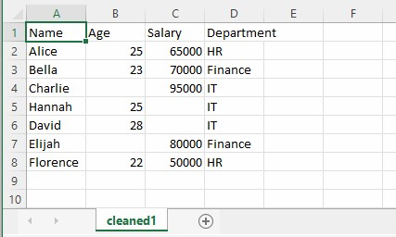

**Output Explanation:**

1. **Input**: A CSV file containing rows, some of which may be fully duplicated.
2. **Process**: Removes all but one occurrence of duplicate rows.
3. **Output**: A new CSV file (cleaned1.csv) where all duplicate rows are removed, retaining only unique rows.

**Title : Finding and removing Noisy data-Bining , Boxplot**

**Description :**

* **Binning**:
  + Smooths noisy data by grouping values into bins (ranges) and replacing them with a representative value (mean, median, or boundary values of the bin).
  + Effective for numerical data with random fluctuations.
* **Boxplot**:
  + A visual method to detect outliers (potential noise) using the interquartile range (IQR).
  + Data points outside the "whiskers" of the boxplot are often considered noisy.

**Code :**

import pandas as pd import numpy as np import matplotlib.pyplot as plt

# Load the dataset df = pd.read_csv("Sheet1.csv")

# Display the first few rows to understand the structure of the data print("sheet1.csv \n", df.head())

# Get the shape (number of rows and columns) of the dataframe print("\n(row,column) : ", df.shape)

# ----------- Boxplot to detect outliers -----------# Boxplot for 'Salary' column to visualize outliers plt.figure(figsize=(8, 6)) plt.boxplot(df['Salary']) plt.title("Boxplot of Salary") plt.ylabel("Salary") plt.show()

# Find outliers in the 'Salary' column using IQR (Interquartile Range) method

Q1 = df['Salary'].quantile(0.25) Q3 = df['Salary'].quantile(0.75)

IQR = Q3 - Q1

# Define outlier boundaries lower_bound = Q1 - 1.5 * IQR upper_bound = Q3 + 1.5 * IQR

# Print the outlier boundaries

print(f"\nLower bound: {lower_bound}, Upper bound: {upper_bound}")

# Remove outliers in the 'Salary' column

df_no_outliers = df[(df['Salary'] >= lower_bound) & (df['Salary'] <= upper_bound)]

# Display the dataframe without outliers

print("\n DataFrame after removing outliers from 'Salary' column: \n", df_no_outliers)

# Check for changes in the shape of the dataframe after removing outliers print("\n New shape after removing outliers: ", df_no_outliers.shape)

**Code explanation :**

1. **Loading the dataset**:
   * pd.read_csv("Sheet1.csv") loads the CSV file into a DataFrame.
   * The .head() method displays the first few rows of the DataFrame to understand its structure.
2. **Boxplot Visualization**:
   * The plt.boxplot(df['Salary']) generates a boxplot for the Salary column to visually detect outliers.
   * plt.title("Boxplot of Salary") sets the title of the plot, and plt.ylabel("Salary") adds a label to the y-axis.
3. **IQR Calculation**:
   * **Interquartile Range (IQR)** is calculated by:
     + Q1 = df['Salary'].quantile(0.25) gives the first quartile (25th percentile).
     + Q3 = df['Salary'].quantile(0.75) gives the third quartile (75th percentile).
     + IQR = Q3 - Q1 calculates the interquartile range.
4. **Outlier Boundaries**:
   * The boundaries for detecting outliers are defined as:
     + **Lower Bound**: Q1 - 1.5 * IQR
     + **Upper Bound**: Q3 + 1.5 * IQR o These bounds are printed for reference.
5. **Remove Outliers**:
   * The DataFrame is filtered to remove rows where the Salary value falls outside the IQR range: df[(df['Salary'] >= lower_bound) & (df['Salary'] <= upper_bound)].
   * The cleaned dataset (without outliers) is stored in df_no_outliers.
6. **Displaying the Data**:
   * The df_no_outliers DataFrame is displayed to show the data after removing outliers.
   * The .shape attribute is used to show the number of rows and columns before and after removing outliers, indicating the changes in the dataset.

**Explanation of parameters of methods used :**

**quantile(0.25)**: Returns the value below which 25% of the data lies (Q1). **quantile(0.75)**: Returns the value below which 75% of the data lies (Q3).

**IQR**: The difference between Q3 and Q1, representing the range within which the central 50% of data lies.

**plt.boxplot()**: Plots a boxplot to visualize the distribution of data and identify outliers.

**df[(df['Salary'] >= lower_bound) & (df['Salary'] <= upper_bound)]**: Filters the rows of the DataFrame to exclude outliers by using the calculated IQR bounds.

**Output :**

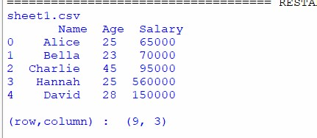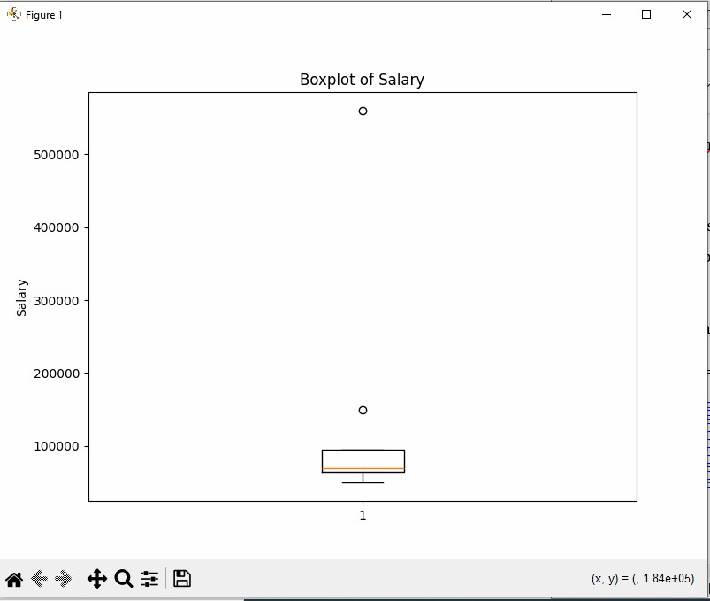

**Output Explanation :**

The provided **boxplot of Salary** represents the distribution of salary data and highlights potential outliers:

1. **Box**: The box represents the **interquartile range (IQR)**, which includes the middle 50% of the salary data. It is bounded by the **25th percentile (Q1)** and **75th percentile (Q3)**.
2. **Whiskers**: The lines extending from the box are called whiskers. They represent the range of salary data within **1.5 times the IQR**. Any data points beyond the whiskers are considered potential outliers.
3. **Outliers**: The dots ( ) above the whiskers indicate **outliers**, which are salary values that are significantly higher than the rest of the data. In this case, the boxplot shows a few high-value salaries above 100,000.
4. **X-Axis and Y-Axis**:
   * The **x-axis** represents the salary data as a single category.
   * The **y-axis** represents salary values, showing the range of salaries from the lowest to the highest, with the box indicating where most of the data is clustered.

**Practical 2**

**AIM : Data Cleaning - 2**

**1. Data in wrong format Data set :**

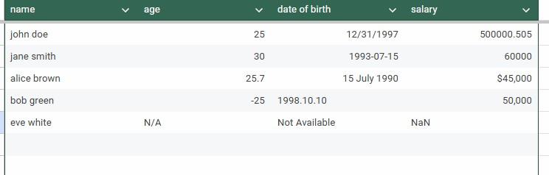

**Description:**

**Data in wrong format** refers to data that is incorrectly structured or represented, making it unsuitable for analysis. This includes:

* **Incorrect data types** (e.g., numbers as text, dates as strings)
* **Missing or null values** (represented as placeholders like "N/A")
* **Inconsistent formats** (e.g., mixed date formats or units)
* **Invalid values** (e.g., negative ages, outlier salaries)
* **Duplicated data** (identical rows repeated)
* **Encoding issues** (e.g., special characters incorrectly stored)

Handling this involves **data cleaning** (converting types, fixing values), **standardization** (consistent formatting), and **validation** to ensure the data is usable for analysis.

**Code :**

import pandas as pd from dateutil import parser

# Load the CSV file

file_path = "Sheet2A.csv" # Replace with your file path df = pd.read_csv(file_path)

# Step 1: Standardize column names df.columns = df.columns.str.strip().str.lower() # Convert to lowercase and strip spaces

# Step 2: Clean the 'name' column df['name'] = df['name'].str.strip().str.title()

# Step 3: Clean the 'age' column

# Convert to numeric, handle missing/invalid values, and set negative ages to 18 df['age'] = pd.to_numeric(df['age'], errors='coerce').fillna(18).apply(lambda x: max(int(x), 18))

# Step 4: Clean the 'salary' column df['salary'] = ( df['salary']

.replace('[\$,]', '', regex=True) # Remove '$' and commas

.fillna(0) # Handle missing values

.astype(float) # Convert to float

)

# Step 5: Clean the 'date of birth' column

# Custom date parser function to handle various formats def parse_date(value): try:

return parser.parse(value).date() # Use dateutil.parser for flexible date parsing except: return pd.NaT # Return NaT for invalid dates

# Replace invalid values and apply the custom date parser df['date of birth'] = df['date of birth'].replace('Not Available', pd.NaT).apply(parse_date)

# Step 6: Validate and print cleaned data

print("\nCleaned Data:") print(df)

# Save cleaned data to a new CSV file cleaned_file_path = "cleaned_data.csv" df.to_csv(cleaned_file_path, index=False) print(f"\nCleaned data saved to {cleaned_file_path}")

**Code explanation :**

This Python code reads a CSV file containing data with potential formatting issues (such as invalid ages, missing dates, and improperly formatted salaries). It processes and cleans the data as follows:

1. **Standardizes column names**: Converts column names to lowercase and strips extra spaces.
2. **Cleans the name column**: Removes extra spaces and formats names in title case.
3. **Cleans the age column**: Converts non-numeric values to NaN, replaces missing or invalid data with 18, and ensures no negative ages are present.
4. **Cleans the salary column**: Strips dollar signs and commas, then converts the salary values to floats.
5. **Cleans the date of birth column**: Handles multiple date formats and replaces invalid dates with NaT (Not a Timestamp).
6. **Saves cleaned data**: The cleaned data is saved into a new CSV file.

**Explanation of parameters of methods used :**

pd.read_csv(file_path):

* file_path: The path to the CSV file that is being read into the DataFrame.

df.columns.str.strip().str.lower():

* str.strip(): Removes any leading and trailing spaces from the column names.
* str.lower(): Converts column names to lowercase for consistency. pd.to_numeric(df['age'], errors='coerce'):
* df['age']: The column containing age data.
* errors='coerce': Invalid values (non-numeric values) are replaced with NaN.

.fillna(18):

* Replaces any NaN (missing) values in the age column with 18.

.apply(lambda x: max(int(x), 18)):

* Ensures that no age value is less than 18 by replacing negative values with 18.

.replace('[\$,]', '', regex=True):

* Removes dollar signs ($) and commas from the salary column using regular expressions.

parser.parse(value).date():

* value: The string representing a date.
* parser.parse(value): Tries to parse a string into a valid date using the dateutil.parser library, which supports various date formats.

pd.NaT:

* Represents missing or invalid date entries in the date of birth column. df.to_csv(file_path, index=False):
* file_path: The path where the cleaned data will be saved as a CSV file.
* index=False: Excludes the DataFrame index from the saved CSV file.

**Output :**

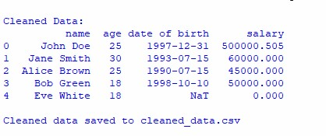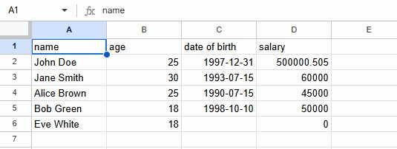

**Output Explanation :**

* **name**: All names are stripped of extra spaces and converted to title case (e.g., "john doe" → "John Doe").
* **age**: Invalid, missing, or negative age values are replaced with the default value 18.
* **date of birth**: Dates are properly formatted to YYYY-MM-DD (e.g., "12/31/1997" → "1997-12-31"). Invalid entries like "Not Available" are replaced with NaT.
* **salary**: Dollar signs and commas are removed, and the column is converted to numeric format. Missing values are replaced with 0.00.

**2. scaling min-max, normalization**

**Description:**

Min-max scaling is a method to rescale data to a specific range, typically [0, 1] or [1, 10]. It transforms the data by subtracting the minimum value and dividing by the range (max - min), then adjusting to the desired scale. This technique ensures that all data values are within the same range, preserving their relative proportions.

**Code Explanation:**

* Loads data and converts 'Age' and 'Salary' columns to numeric values.
* Drops rows with missing values in 'Age' or 'Salary'.
* Scales 'Age' and 'Salary' values to the range 1-10 using the min_max_scaling() function.
* Displays the relevant
* columns of the dataframe.

**Code:**

**# Min-max scaling** import pandas as pd

# Load data from a CSV file

df = pd.read_csv('Sheet1.csv', delimiter=',')

# Convert the target columns to numeric (replace column references as needed) df['Age'] = pd.to_numeric(df['Age'], errors='coerce') # Converts non-numeric to

NaN

df['Salary'] = pd.to_numeric(df['Salary'], errors='coerce') # Converts nonnumeric to NaN

# Drop rows with NaN values in 'Age' or 'Salary' (optional, if invalid data exists) df = df.dropna(subset=['Age', 'Salary']) # Drop rows with NaN in 'Age' or 'Salary'

# Define min-max scaling function def min_max_scaling(column, new_min, new_max):

return ((column - column.min()) / (column.max() - column.min())) * (new_max - new_min) + new_min

# Apply scaling to both 'Age' and 'Salary' columns (scaling to the range 1-10) df['Age_scaled'] = min_max_scaling(df['Age'], 1, 10) df['Salary_scaled'] = min_max_scaling(df['Salary'], 1, 10)

# Display the first few rows of the dataframe with the scaled 'Age' and 'Salary' print(df[['Name', 'Age', 'Age_scaled', 'Salary', 'Salary_scaled']])

**Output Explanation:**

The 'Age' and 'Salary' values are scaled to the range 1-10.

For 'Age', 22 scales to 1, and 25 scales to 10.

For 'Salary', 50,000 scales to 1, and 70,000 scales to 10.

**Output:**

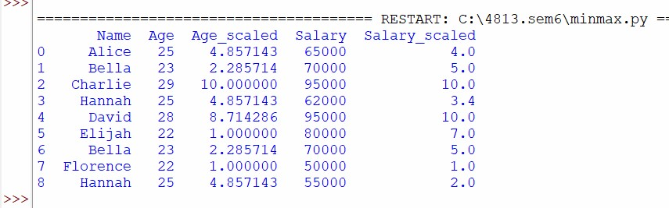

**Description:** Normalization is a technique to adjust data to a standard range, typically [0, 1]. It is similar to min-max scaling, but instead of scaling to a custom range, it standardizes the values by adjusting them within a fixed range, commonly [0, 1]. This ensures that all data points are on a similar scale, improving the performance of certain algorithms.

**Code Explanation:**

* Loads data and converts the 'Age' and 'Salary' columns to numeric values.
* Drops rows with missing values in 'Age' or 'Salary'.
* Normalizes 'Age' and 'Salary' values to the range [0, 1] using the normalization formula.
* Displays the relevant columns of the dataframe.

**Code:**

**#Z-score normalization** import pandas as pd

# Load data from a CSV file

df = pd.read_csv('Sheet1.csv', delimiter=',') # Use ',' for the standard CSV format, or adjust delimiter as needed

# Convert the target columns to numeric (replace column references as needed)

df['Age'] = pd.to_numeric(df['Age'], errors='coerce') # Converts non-numeric to NaN df['Salary'] = pd.to_numeric(df['Salary'], errors='coerce') # Converts non-numeric to NaN

# Drop rows with NaN values in 'Age' or 'Salary' (optional, if invalid data exists) df = df.dropna(subset=['Age', 'Salary']) # Drop rows with NaN in 'Age' or 'Salary'

# Define Z-score normalization function def z_score_normalization(column): return (column - column.mean()) / column.std()

# Apply Z-score normalization to both 'Age' and 'Salary' columns df['Age_zscore'] = z_score_normalization(df['Age']) df['Salary_zscore'] = z_score_normalization(df['Salary'])

# Print the dataframe with original and normalized values print(df[['Name', 'Age', 'Age_zscore', 'Salary', 'Salary_zscore']])

**Output Explanation:**

The 'Age' and 'Salary' values are normalized to the range [0, 1].

For 'Age', the minimum value (22) becomes 0, and the maximum value (29) becomes 1.

For 'Salary', the minimum value (50,000) becomes 0, and the maximum value (95,000) becomes

**Output:**

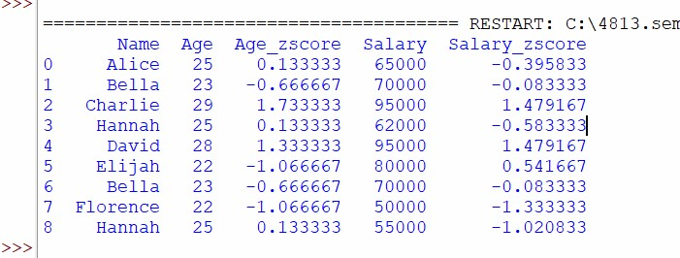

**Practical 3**

**Aim : Data Preprocessing**

**1. Correlation (Heatmap)**

**Description:**

Correlation is a statistical measure that describes the strength and direction of a relationship between two variables. The value of correlation ranges from -1 to 1:

**Code:**

import pandas as pd import seaborn as sns import matplotlib.pyplot as plt

# Load data from the Excel file

# Replace 'your_file.xlsx' with the path to your Excel file df = pd.read_excel('sheetprac2.xlsx')

# Compute the correlation matrix correlation_matrix = df.corr()

# Create the heatmap plt.figure(figsize=(6, 4)) sns.heatmap(correlation_matrix, annot=True, cmap='coolwarm', fmt='.2f', linewidths=0.5)

# Display the plot plt.title('Correlation Heatmap') plt.show()

**Code explanation :**

**Load Data:**

* df = pd.read_excel('sheetprac2.xlsx'): Loads data from the Excel file into a DataFrame.

**Calculate Correlation:**

* correlation_matrix = df.corr(): Computes the correlation matrix.

**Create Heatmap:**

* sns.heatmap(): Generates a heatmap with correlation values displayed, using a color scale (coolwarm).

**Display Plot:**

* plt.show(): Displays the heatmap.

● 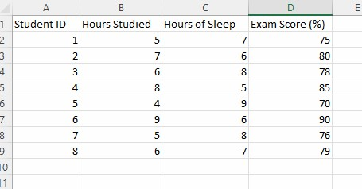

**Output :**

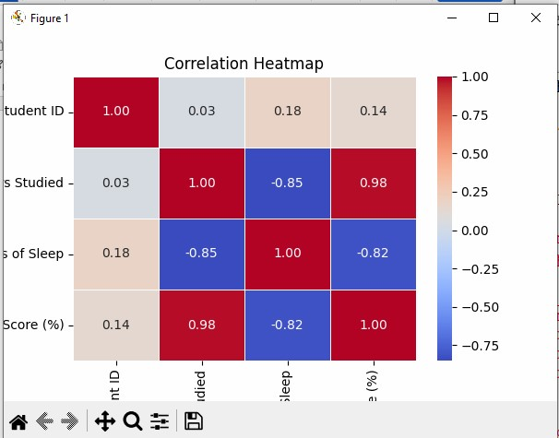

**Output Explanation :**

* The heatmap visually shows the correlation between variables, with each cell representing the correlation value.
* The values range from -1 to 1:
* 1 indicates perfect positive correlation (strong direct relationship).
* -1 indicates perfect negative correlation (strong inverse relationship).
* 0 indicates no correlation.
* The color intensity corresponds to the correlation values (red for high positive and blue for high negative, depending on the color palette used).

**2.Chi - square Data set :**

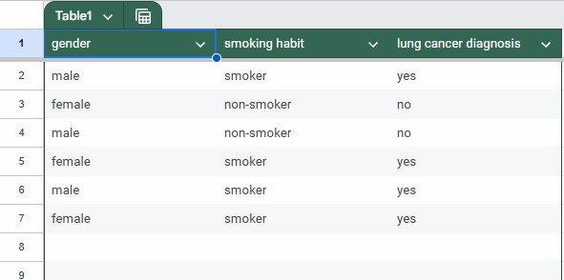

**Description :**

The **Chi-Square Test** is a statistical method used to determine whether there is a significant association or relationship between two categorical variables. It compares the observed frequencies in each category with the expected frequencies (if the variables were independent).

* **Null Hypothesis (H0)**: The two variables are independent (no relationship).
* **Alternative Hypothesis (Ha)**: The two variables are dependent (a relationship exists).

**Code :**

import pandas as pd import scipy.stats as stats # Load the CSV file (adjust the path to your file) file_path = "smokerdata.csv" # Replace with your file path df = pd.read_csv(file_path)

# Step 1: Create a contingency table for 'Gender', 'Smoking Habit', and 'Lung Cancer Diagnosis' contingency_table = pd.crosstab([df['gender'], df['smoking habit']], df['lung cancer diagnosis'])

# Step 2: Perform the Chi-Square test chi2_stat, p_value, dof, expected = stats.chi2_contingency(contingency_table)

# Step 3: Print the results print(f"Chi-Square Statistic: {chi2_stat}") print(f"P-Value: {p_value}") print(f"Degrees of Freedom: {dof}") print(f"Expected Frequencies:\n{expected}")

# Step 4: Interpret the result alpha = 0.05 # significance level (5%)

if p_value < alpha:

print("\nResult: The variables are dependent on each other

(reject the null hypothesis).") else:

print("\nResult: The variables are independent of each other (fail to reject the null hypothesis).")

**Code explanation :**

This code performs a Chi-Square Test on a dataset with three categorical variables: **Gender**, **Smoking Habit**, and **Lung Cancer Diagnosis**. The test checks if there is a significant relationship between these variables.

**Steps in the Code:**

1. **Loading the Data**: The dataset is loaded from a CSV file using pd.read_csv().
2. **Creating a Contingency Table**: The pd.crosstab() function is used to create a contingency table, which shows the frequency distribution of the variables.
3. **Chi-Square Test**: The test is performed using stats.chi2_contingency() to calculate the Chi-Square statistic, pvalue, degrees of freedom (dof), and expected frequencies.
4. **Interpreting the Results**: If the p-value is less than 0.05 (significance level), we reject the null hypothesis and conclude that the variables are **dependent**. Otherwise, they are **independent**.

**Explanation of parameters of methods used :**

**pd.read_csv(file_path)**: Reads the CSV file into a pandas DataFrame.

**pd.crosstab()**: Creates a contingency table, which crosstabulates two or more categorical variables.

**stats.chi2_contingency()**: Performs the Chi-Square test. It returns:

* **chi2_stat**: The Chi-Square statistic, indicating the discrepancy between the observed and expected frequencies.
* **p_value**: The p-value, used to determine the statistical significance.
* **dof**: Degrees of freedom, based on the number of categories in the variables.
* **expected**: Expected frequencies based on the null hypothesis.

**Output:**

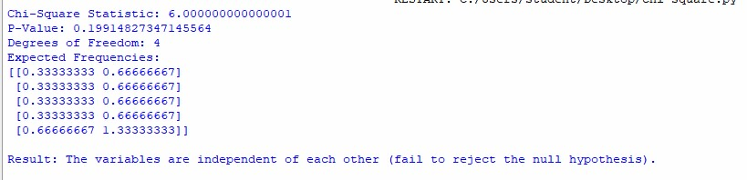

**Output Explanation :**

The output of the code will print:

* The **Chi-Square Statistic**: A value that tells you how much the observed data deviates from the expected values under the assumption of independence.
* The **P-Value**: A measure used to decide whether to reject the null hypothesis. If it's less than 0.05, the variables are considered **dependent**.
* The **Degrees of Freedom (dof)**: The number of independent values that can vary in the dataset.
* The **Expected Frequencies**: The expected values under the null hypothesis.

**Practical 4**

**AIM : EDA**

# Mean, Median

**Source Code:** import pandas as pd df = pd.read_csv(r'C:\Users\dtirt\Desktop\Folder\Codes\College\CarData - Sheet1.csv')

mean_units_sold = df['UnitsSold'].mean() median_units_sold = df['UnitsSold'].median()

print(f"Mean Units Sold: {mean_units_sold}") print(f"Median Units Sold: {median_units_sold}") Output:

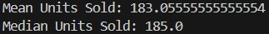

# Heatmap

**Source Code:**

import pandas as pd import numpy as np import seaborn as sns import matplotlib.pyplot as plt df = pd.read_csv(r'C:\Users\dtirt\Desktop\Folder\Codes\College\CarData - Sheet1.csv')

non_numeric_columns = df.select_dtypes(exclude=[np.number]).columns print("Non-numeric columns:", non_numeric_columns)

for col in non_numeric_columns:

if pd.api.types.is_string_dtype(df[col]): try:

df[col] = pd.to_datetime(df[col]) df[col] = df[col].astype(int) / 10**9 except Exception as e:

print(f"Could not convert column {col}: {e}") df.drop(columns=[col], inplace=True) df_numeric = df.select_dtypes(include=[np.number]) correlation_matrix = df_numeric.corr()

sns.heatmap(correlation_matrix, annot=True, cmap='coolwarm', linewidths=0.5) plt.title("Correlation Heatmap") plt.show()

**Output:**

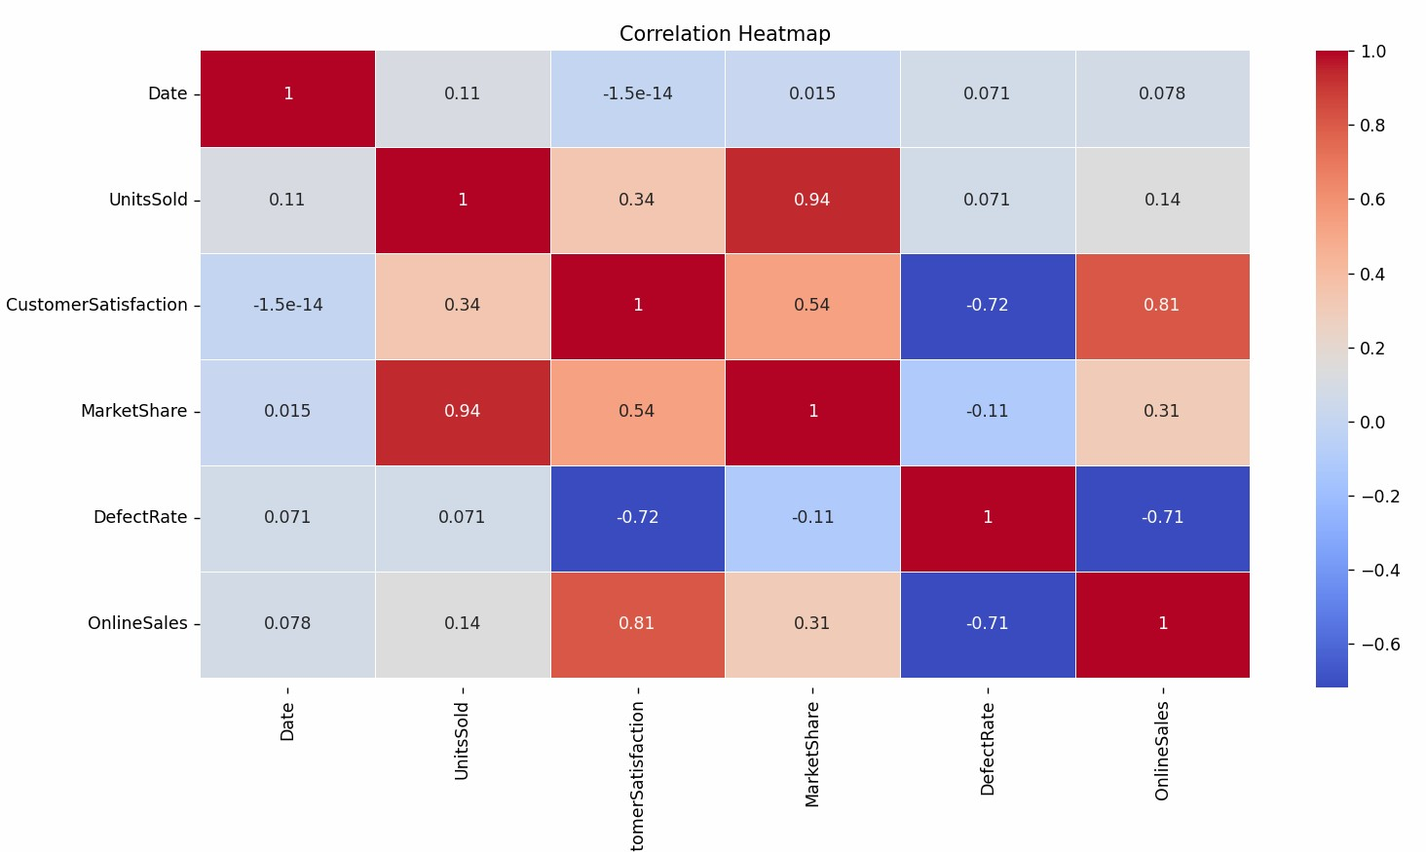

# Pie Chart

**Source Code:**

import pandas as pd import matplotlib.pyplot as plt df = pd.read_csv(r'C:\Users\dtirt\Desktop\Folder\Codes\College\CarData - Sheet1.csv')

market_share = df.groupby('CarModel')['MarketShare'].sum() market_share.plot(kind='pie', autopct='%1.1f%%', startangle=90, cmap='Set3') plt.title("Market Share by Car Model") plt.ylabel('') plt.show()

**Output:**

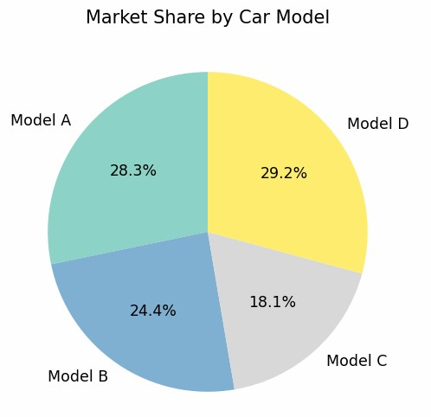

# Bar Chart

**Source Code:**

import pandas as pd import matplotlib.pyplot as plt df = pd.read_csv(r'C:\Users\dtirt\Desktop\Folder\Codes\College\CarData - Sheet1.csv') df['Revenue (in $)'] = df['Revenue (in $)'].str.replace(',', '').astype(float)

revenue = df.groupby('CarModel')['Revenue (in $)'].sum() print("Final Revenue Data:") print(revenue)

if not revenue.empty:

revenue.plot(kind='bar', color='skyblue', figsize=(10, 6)) plt.title("Revenue by Car Model") plt.xlabel("Car Model") plt.ylabel("Revenue (in $)") plt.xticks(rotation=45) plt.grid(axis='y', linestyle='--', alpha=0.7) plt.show() else:

print("No data available to plot.")

**Output:**

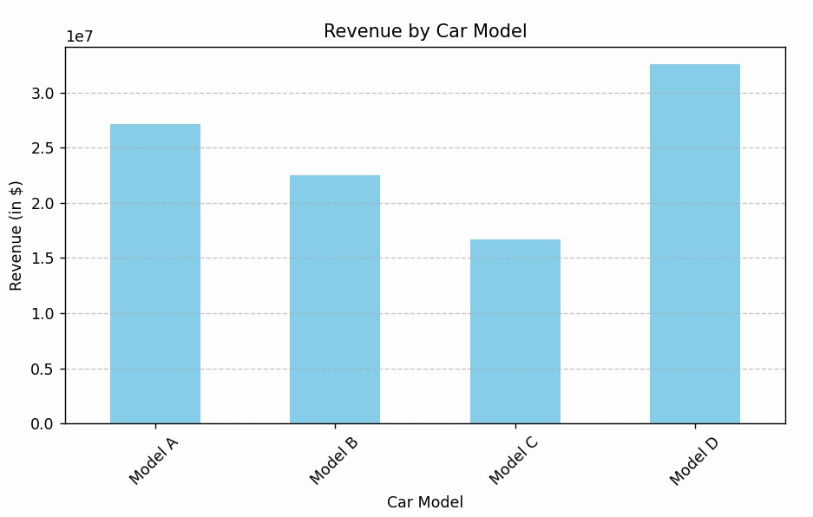

# Line Chart

**Source Code:**

import pandas as pd import matplotlib.pyplot as plt df = pd.read_csv(r'C:\Users\dtirt\Desktop\Folder\Codes\College\CarData - Sheet1.csv')

df['Date'] = pd.to_datetime(df['Date'], errors='coerce') df = df.dropna(subset=['Date']) df = df.sort_values(by='Date') units_sold_over_time = df.groupby('Date')['UnitsSold'].sum()

units_sold_over_time.plot(kind='line', color='orange', figsize=(12, 6)) plt.title("Units Sold Over Time", fontsize=16) plt.xlabel('Date', fontsize=12) plt.ylabel('Units Sold', fontsize=12) plt.grid(True) plt.tight_layout() plt.show()

**Output:**

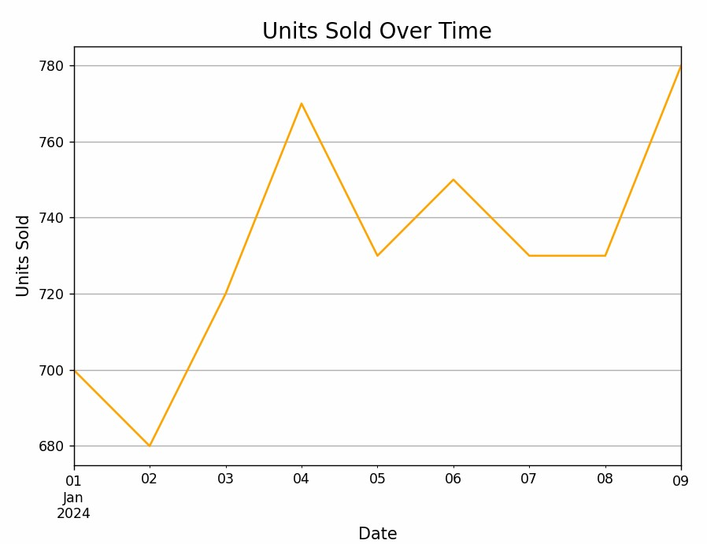

# Doughnut Chart

**Source Code:**

import pandas as pd import matplotlib.pyplot as plt df = pd.read_csv(r'C:\Users\dtirt\Desktop\Folder\Codes\College\CarData - Sheet1.csv') df['Revenue (in $)'] = df['Revenue (in $)'].str.replace(',', '').astype(float) revenue = df.groupby('CarModel')['Revenue (in $)'].sum()

plt.figure(figsize=(8, 8)) plt.pie( revenue, labels=revenue.index, autopct='%1.1f%%', startangle=90, wedgeprops={'width': 0.3}

)

plt.title("Revenue Distribution by Car Model (Doughnut Chart)", fontsize=14)

plt.show()

**Output:**

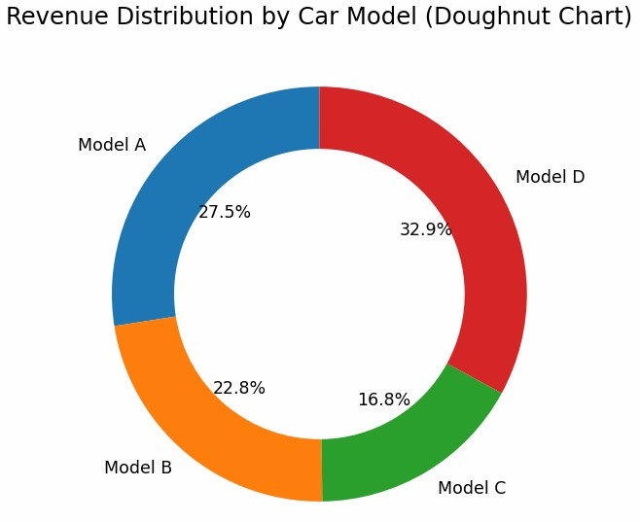

# Scatter Plot

**Source Code:**

import pandas as pd import matplotlib.pyplot as plt df = pd.read_csv(r'C:\Users\dtirt\Desktop\Folder\Codes\College\CarData - Sheet1.csv') plt.scatter(df['CustomerSatisfaction'], df['Revenue (in $)'], alpha=0.6, edgecolors='w', s=100) plt.title("Customer Satisfaction vs Revenue") plt.xlabel('Customer Satisfaction (out of 10)') plt.ylabel('Revenue (in $)') plt.show()

**Output:**

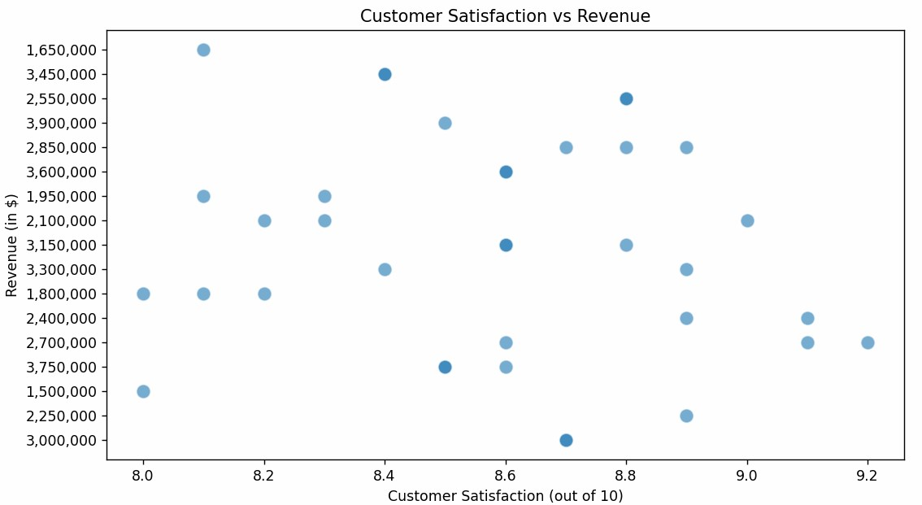

# Box Plot

**Source Code:**

import pandas as pd import seaborn as sns import matplotlib.pyplot as plt df = pd.read_csv(r'C:\Users\dtirt\Desktop\Folder\Codes\College\CarData - Sheet1.csv') sns.boxplot(x='CarModel', y='UnitsSold', data=df) plt.title("Box Plot of Units Sold by Car Model") plt.show()

**Output:**

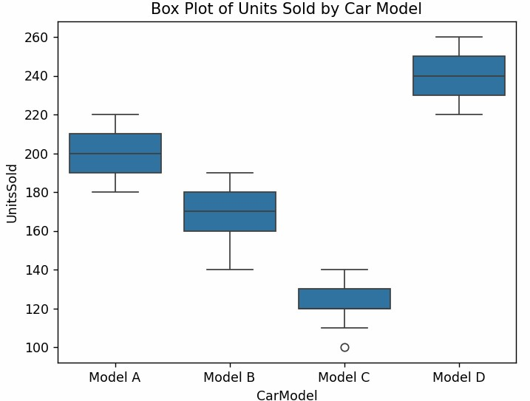

# Pair Plot

**Source Code:**

import pandas as pd import seaborn as sns import matplotlib.pyplot as plt df = pd.read_csv(r'C:\Users\dtirt\Desktop\Folder\Codes\College\CarData - Sheet1.csv') sns.pairplot(df[['UnitsSold', 'Revenue (in $)', 'CustomerSatisfaction', 'MarketShare']]) plt.title("Pair Plot for Selected Variables") plt.show()

**Output:**

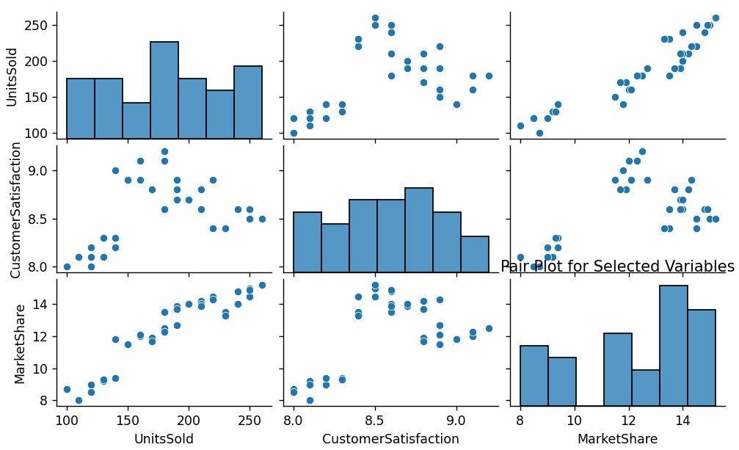

# Violin Chart

**Source Code:**

import pandas as pd import seaborn as sns import matplotlib.pyplot as plt df = pd.read_csv(r'C:\Users\dtirt\Desktop\Folder\Codes\College\CarData - Sheet1.csv')

sns.violinplot(x='CarModel', y='CustomerSatisfaction', data=df, inner='quart') plt.title("Violin Plot for Customer Satisfaction by Car Model")

plt.show()

**Output:**

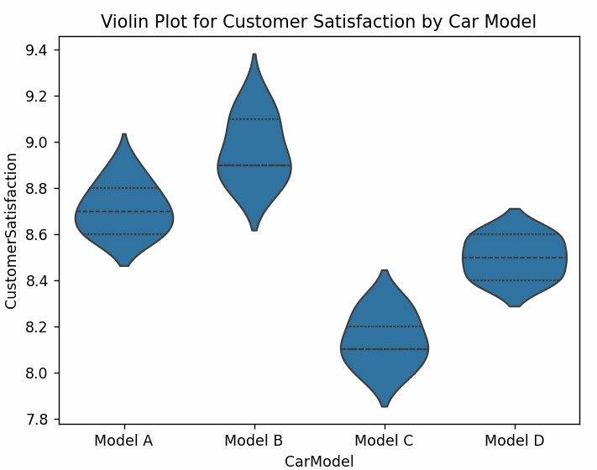

# Joint Plot

**Source Code:**

import pandas as pd import seaborn as sns import matplotlib.pyplot as plt df = pd.read_csv(r'C:\Users\dtirt\Desktop\Folder\Codes\College\CarData - Sheet1.csv')

sns.jointplot(x='UnitsSold', y='Revenue (in $)', data=df, kind='scatter', color='green') plt.suptitle("Joint Plot for Units Sold vs Revenue", y=1.02) plt.show()

**Output:**

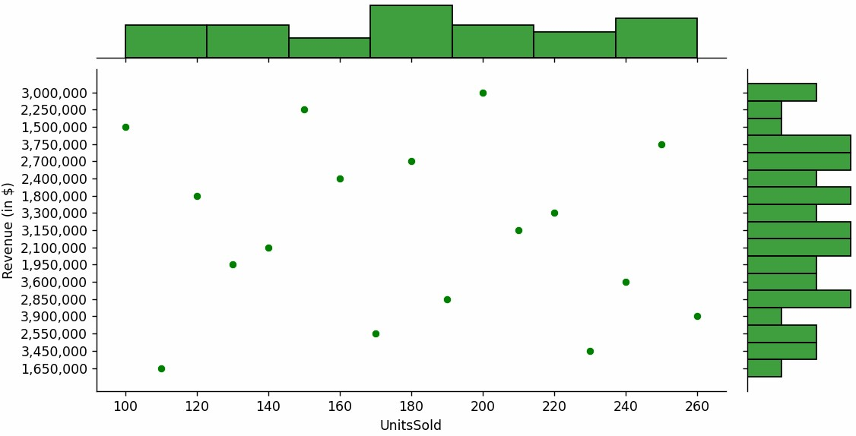

# Scatter with trend line

**Source Code:**

import pandas as pd import seaborn as sns import matplotlib.pyplot as plt df = pd.read_csv(r'C:\Users\dtirt\Desktop\Folder\Codes\College\CarData - Sheet1.csv') df['Revenue (in $)'] = df['Revenue (in $)'].str.replace(',', '').astype(float) plt.figure(figsize=(10, 6)) sns.regplot( x='UnitsSold', y='Revenue (in $)', data=df,

scatter_kws={'color': 'blue', 'alpha': 0.6}, line_kws={'color': 'red', 'linewidth': 2}

)

plt.title("Scatter Plot with Trendline (Units Sold vs Revenue)", fontsize=16) plt.xlabel("Units Sold", fontsize=12) plt.ylabel("Revenue (in $)", fontsize=12) plt.grid(True, linestyle='--', alpha=0.7) plt.tight_layout() plt.show()

**Output:**

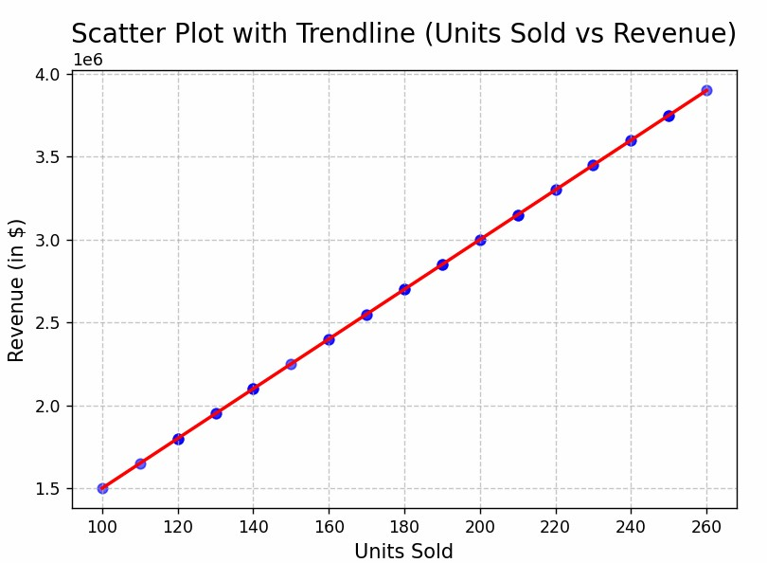

# Histogram of Defect Rate

**Source Code:**

import pandas as pd import matplotlib.pyplot as plt df = pd.read_csv(r'C:\Users\dtirt\Desktop\Folder\Codes\College\CarData - Sheet1.csv')

df['DefectRate'].plot(kind='hist', bins=10, color='purple', edgecolor='black', alpha=0.7) plt.title("Histogram of Defect Rate") plt.xlabel('Defect Rate (%)') plt.ylabel('Frequency') plt.show()

**Output:**

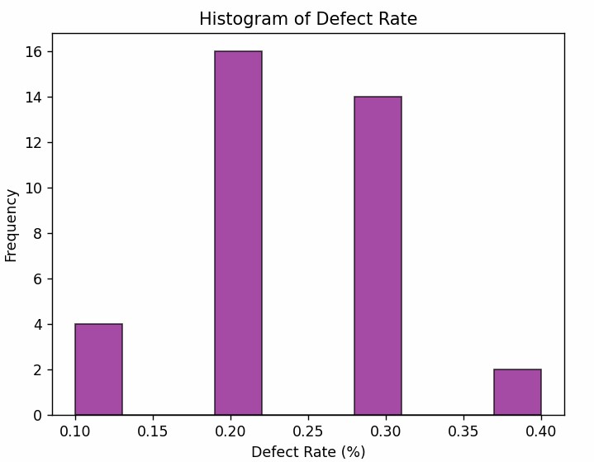

**Practical 5**

**AIM : Linear Regression**

**Aim :**

1. Prediction
2. Comouting error and corr coefficient
3. commenting on Goodness of fit

**Description :**

Linear regression is a statistical method used to model the relationship between a dependent variable (y) and one or more independent variables (x). It fits a straight line to the data, represented as:

y=ax+b

Where:

● a: Slope (rate of change of y with x). ● b: Intercept (value of y when x=0).

The goal is to minimize the difference (error) between the observed values and the predicted values on the line, making it useful for prediction and understanding trends.

**Code :**

import pandas as pd from sklearn.linear_model import LinearRegression from sklearn.metrics import mean_squared_error, r2_score from sklearn.model_selection import train_test_split import numpy as np

# Load the dataset

file_path = r'C:\Users\aj\OneDrive\Desktop\SEM 6\Data

Science\advertising.csv'

# Update this to the actual path if running locally data = pd.read_csv(file_path)

# Step 1: Data overview

# Display the first few rows of the dataset print("Dataset Preview:") print(data.head())

# Step 2: Feature selection (TV budget) and Target (Sales) X = data[['TV']] # Independent variable (TV advertising budget) y = data['Sales'] # Dependent variable (Sales)

# Step 3: Train-test split for model evaluation

X_train, X_test, y_train, y_test = train_test_split(X, y, test_size=0.2, random_state=42)

# Step 4: Initialize and train the Linear Regression model model = LinearRegression() model.fit(X_train, y_train)

# Step 5: Predict on test data y_pred = model.predict(X_test)

# Step 6: Predict future values for new TV budgets

# Convert future_TV_budgets to a DataFrame with the same feature name future_TV_budgets = pd.DataFrame(np.array([[250], [300], [350]]), columns=['TV'])

# Predict future values future_predictions = model.predict(future_TV_budgets)

# Step 7: Compute performance metrics mse = mean_squared_error(y_test, y_pred) # Mean Squared Error r2 = r2_score(y_test, y_pred) # R-squared (Goodness of fit) corr_coefficient = np.corrcoef(data['TV'], data['Sales'])[0, 1] # Correlation coefficient

# Step 8: Outputs print("\nPerformance Metrics:") print(f"Mean Squared Error (MSE): {mse:.2f}") print(f"R-squared (R²): {r2:.2f}") print(f"Correlation Coefficient: {corr_coefficient:.2f}")

print("\nFuture Predictions (Sales for new TV budgets):") for budget, prediction in zip(future_TV_budgets['TV'].values.flatten(), future_predictions):

print(f"TV Budget: ${budget}, Predicted Sales: {prediction:.2f}")

**Code explanation :**

* **Dataset Loading**:
  + The dataset is loaded using pandas from the specified file path. The data contains columns like TV (ad budget) and Sales.
* **Feature Selection**:
  + X (independent variable): TV advertising budget.
  + y (dependent variable): Sales.
* **Train-Test Split**:
  + Splits the data into training (80%) and testing (20%) subsets to evaluate the model on unseen data.
* **Model Training**:
  + A LinearRegression model is initialized and trained using the training data (X_train and y_train).
* **Predictions**:
  + The model predicts sales on the test set (X_test).
  + Predicts sales for specific TV budgets (250, 300, 350).
* **Performance Metrics**:
  + Mean Squared Error (MSE): Measures the average squared difference between actual and predicted sales.
  + R² (R-squared): Indicates how well the model explains the variability in sales.
  + Correlation Coefficient: Measures the linear relationship between TV budget and Sales.

**Variable used :**

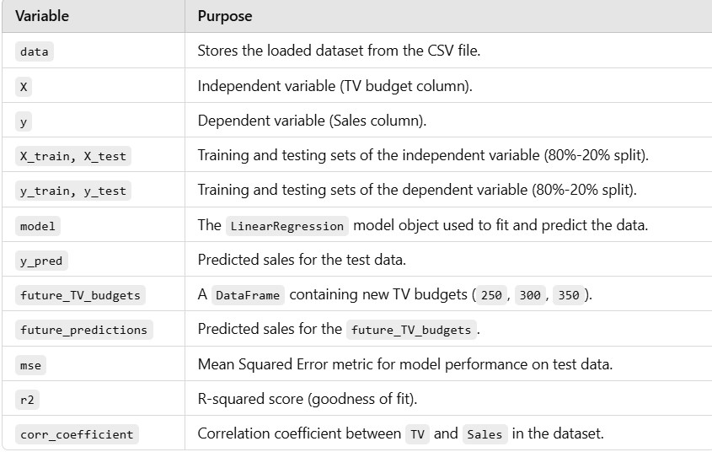

**Output :**

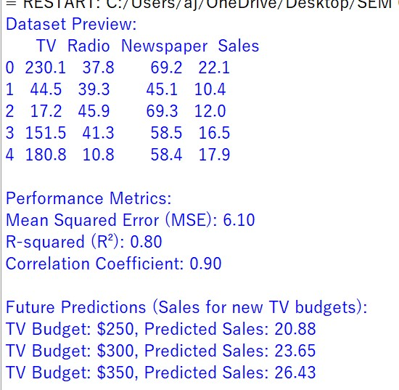

**Output explanation :**

1. **Dataset Preview:** 
   * Shows the first 5 rows of the dataset.
   * Contains the columns: TV, Radio, Newspaper (advertising budgets in thousands of dollars), and Sales (units sold).
2. **Performance Metrics:** 
   * **Mean Squared Error (MSE)**: 6.10
     + This represents the average squared difference between actual and predicted sales. A lower value indicates better model accuracy.
   * **R-squared (R²)**: 0.80
     + This indicates that 80% of the variance in sales is explained by the TV advertising budget, which shows a strong fit.
   * **Correlation Coefficient**: 0.90 o Indicates a strong positive linear relationship between TV advertising budget and Sales.
3. **Future Predictions:** 
   * Predictions of sales for TV advertising budgets of:
     + $250 → **20.88 units** o $300 → **23.65 units** o $350 → **26.43 units**
   * These values show the expected increase in sales as the TV advertising budget increases.

**Conclusion :**

The model demonstrates a **good fit (R² = 0.80),** indicating that TV advertising strongly impacts sales. The predictions provide actionable insights for future budget planning.

**Practical 6**

**AIM : Comparing Classification**

1. Naïve Bayes

Code

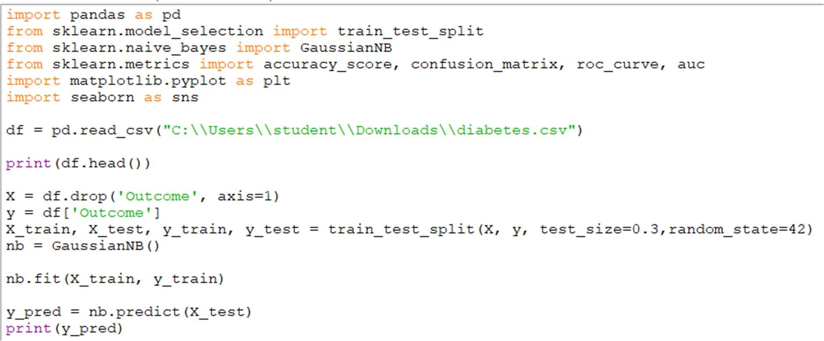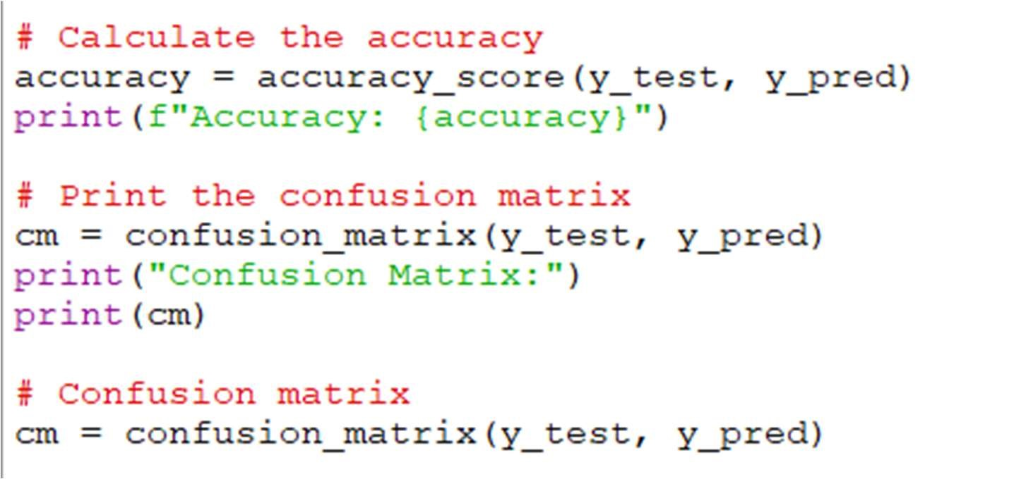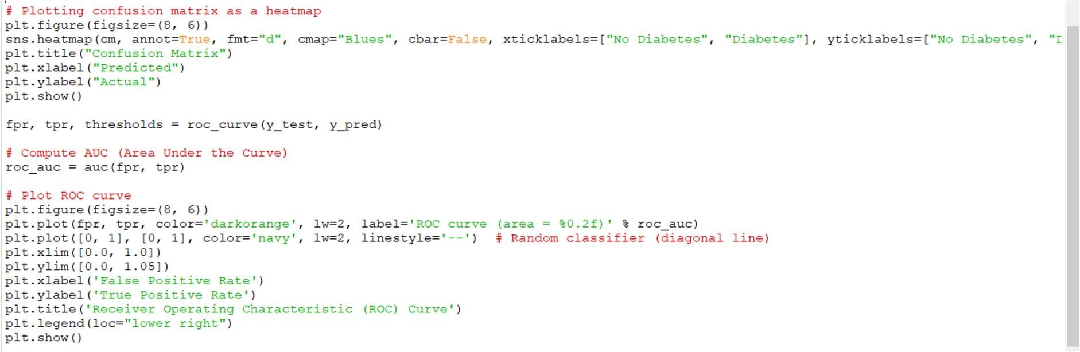

Output

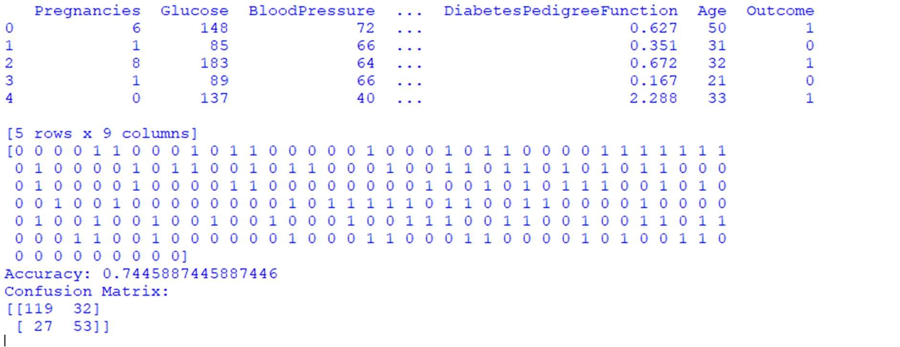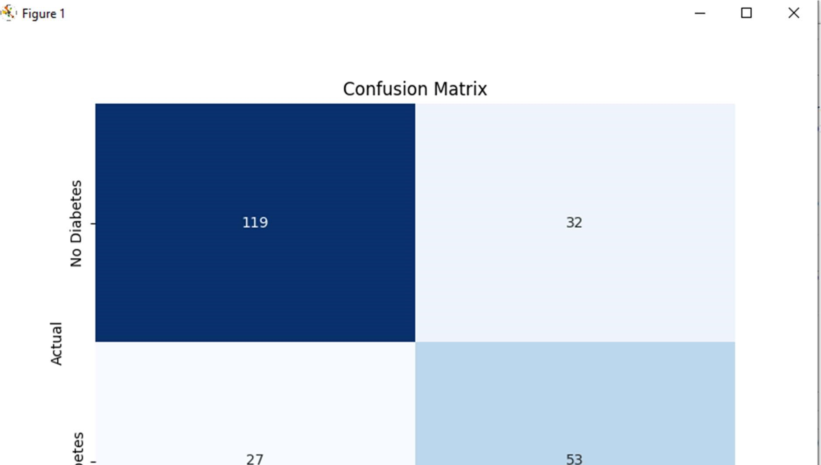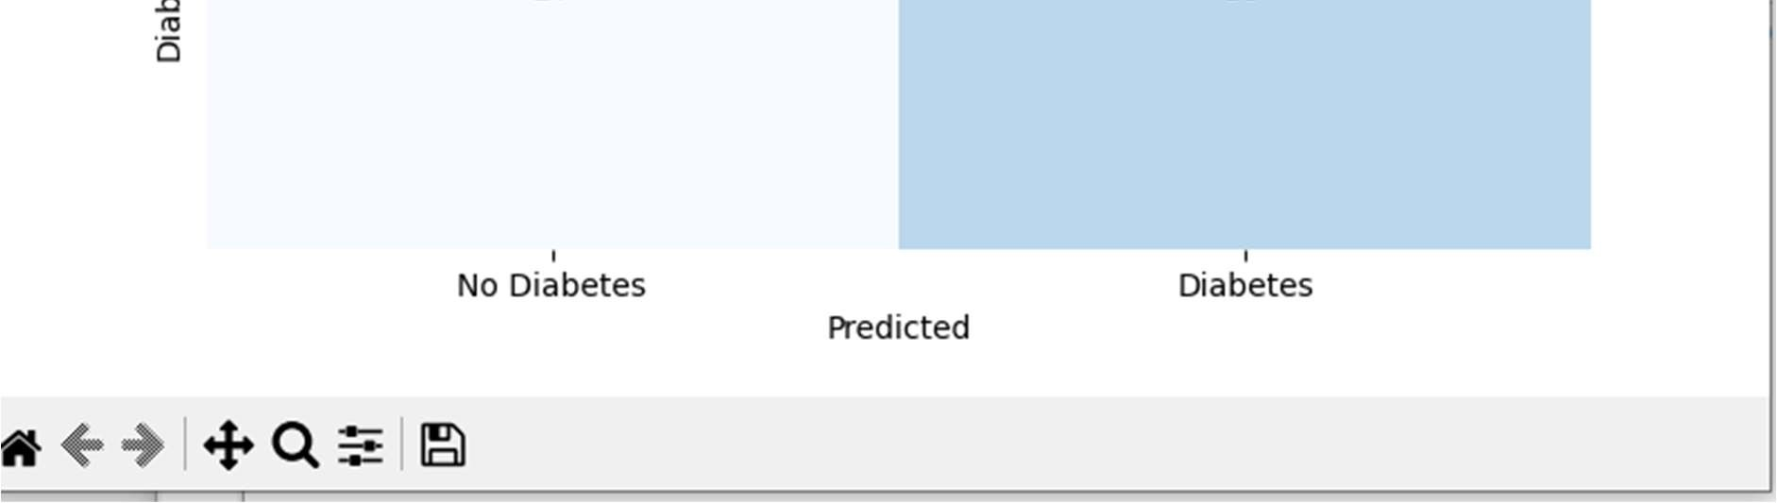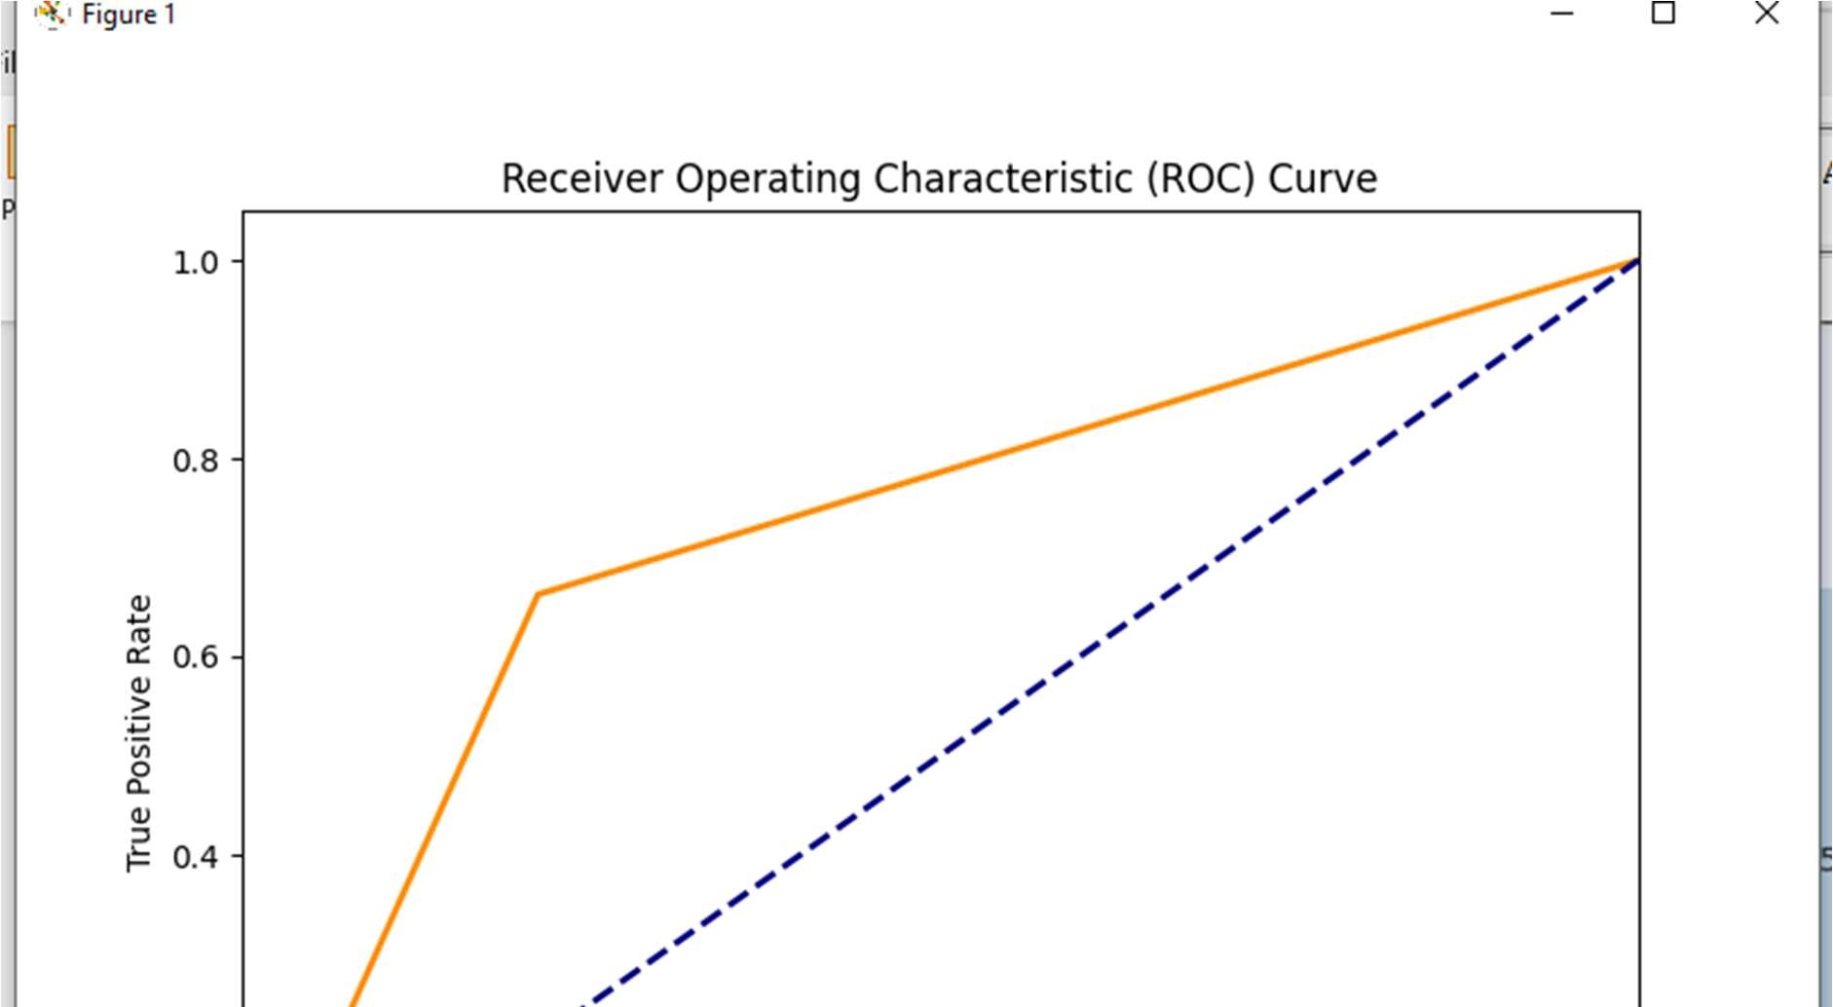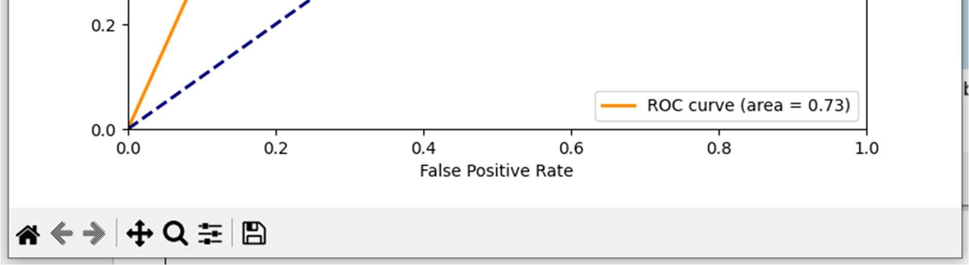

1. PCA (Principal Component Analysis)

Code

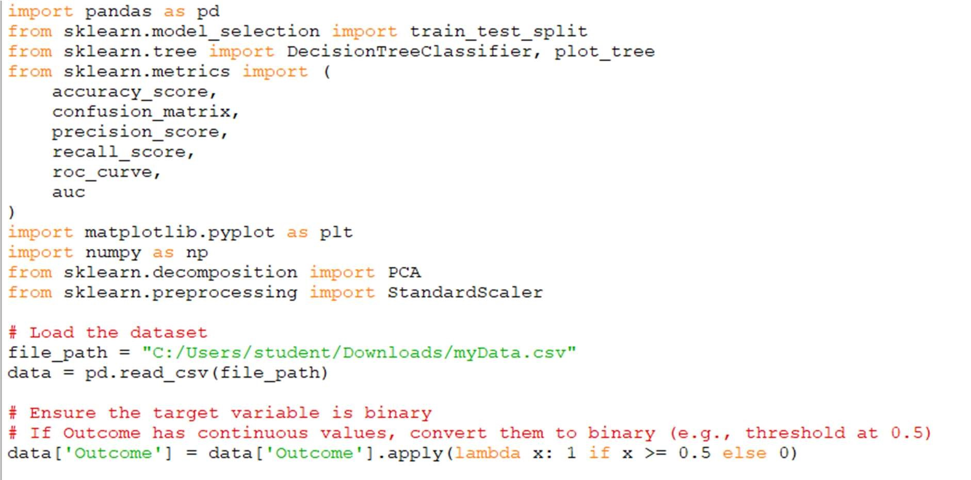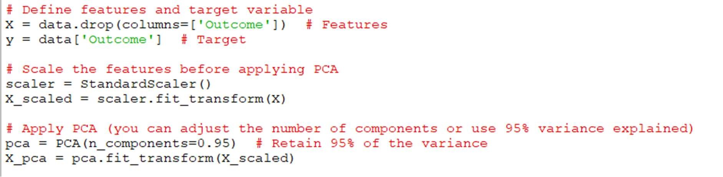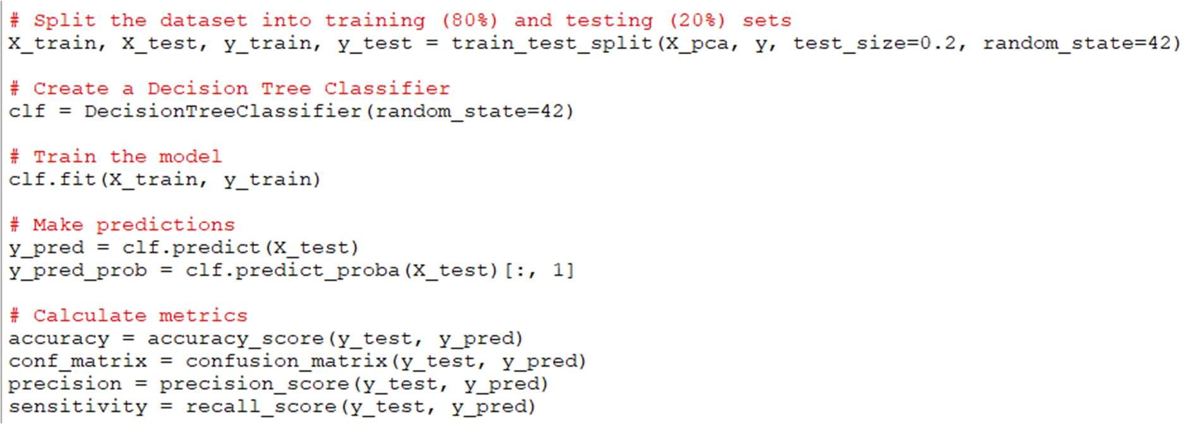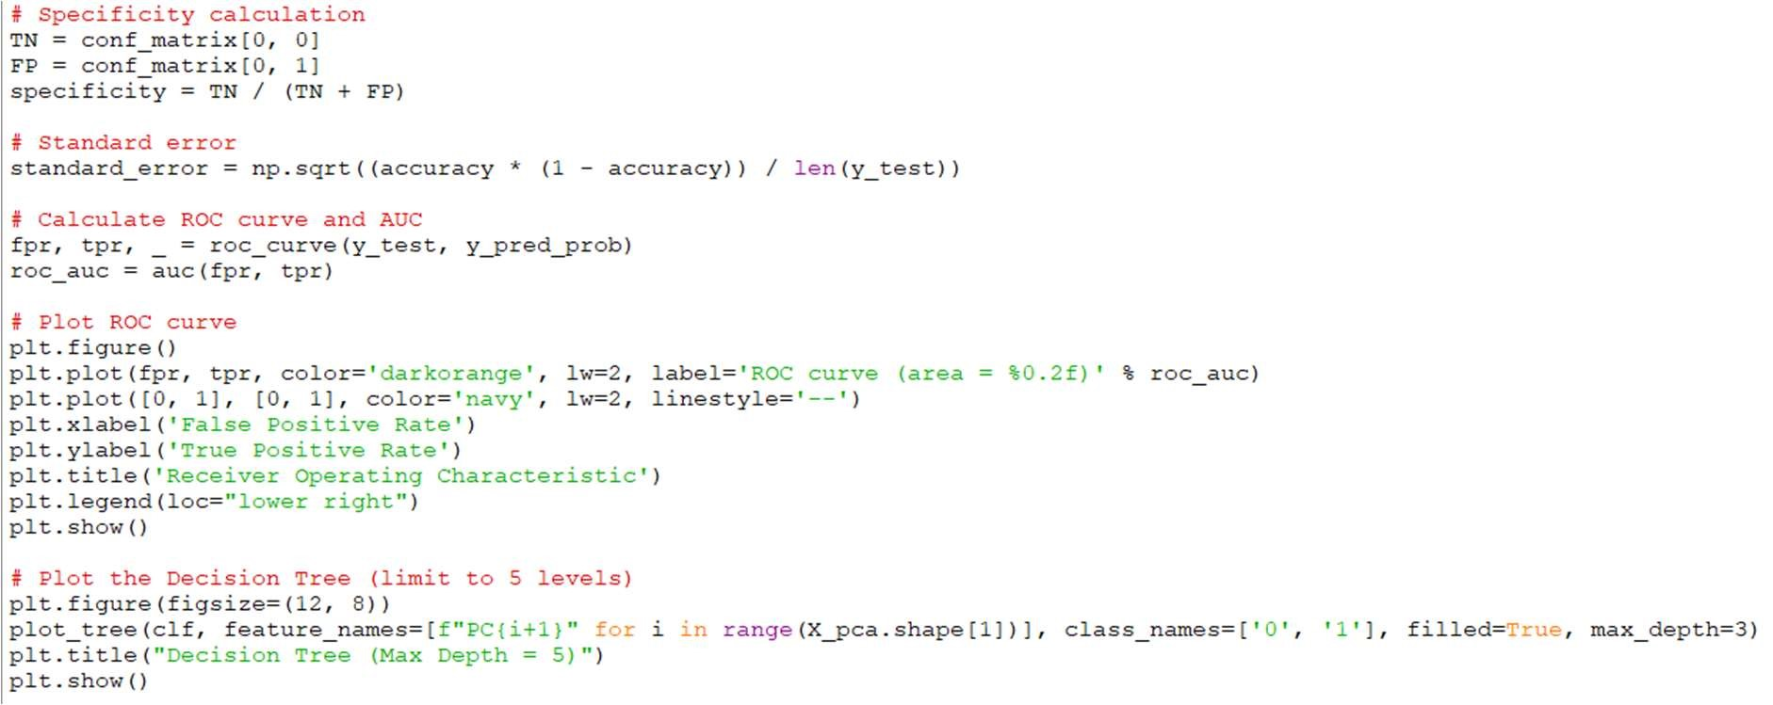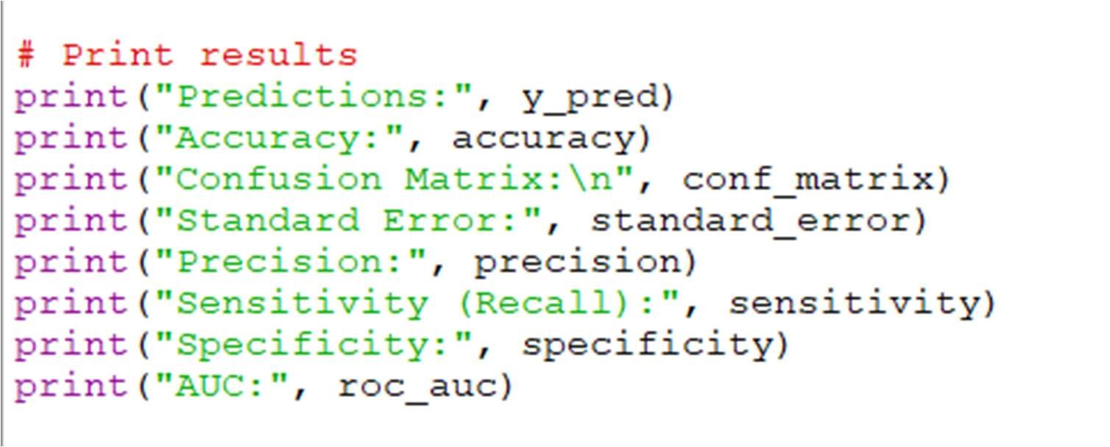

Output

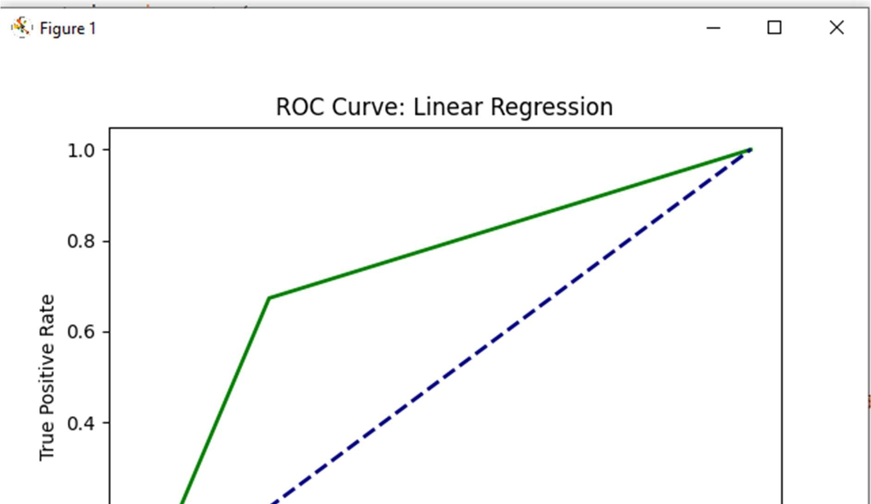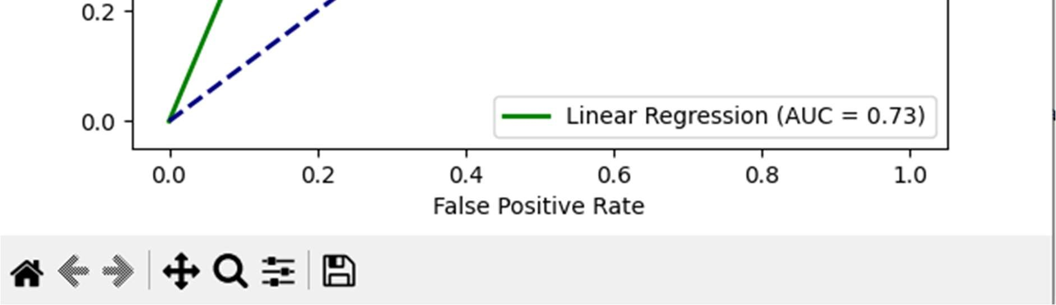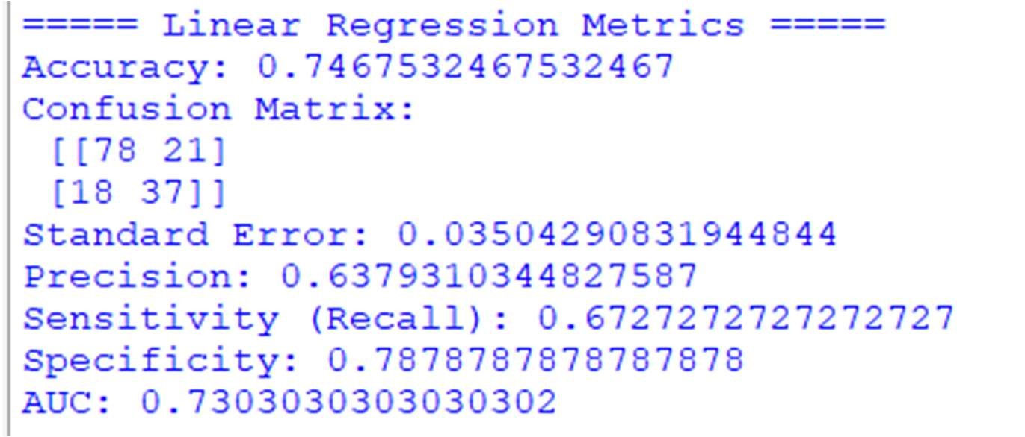

1. Linear Regression

Code

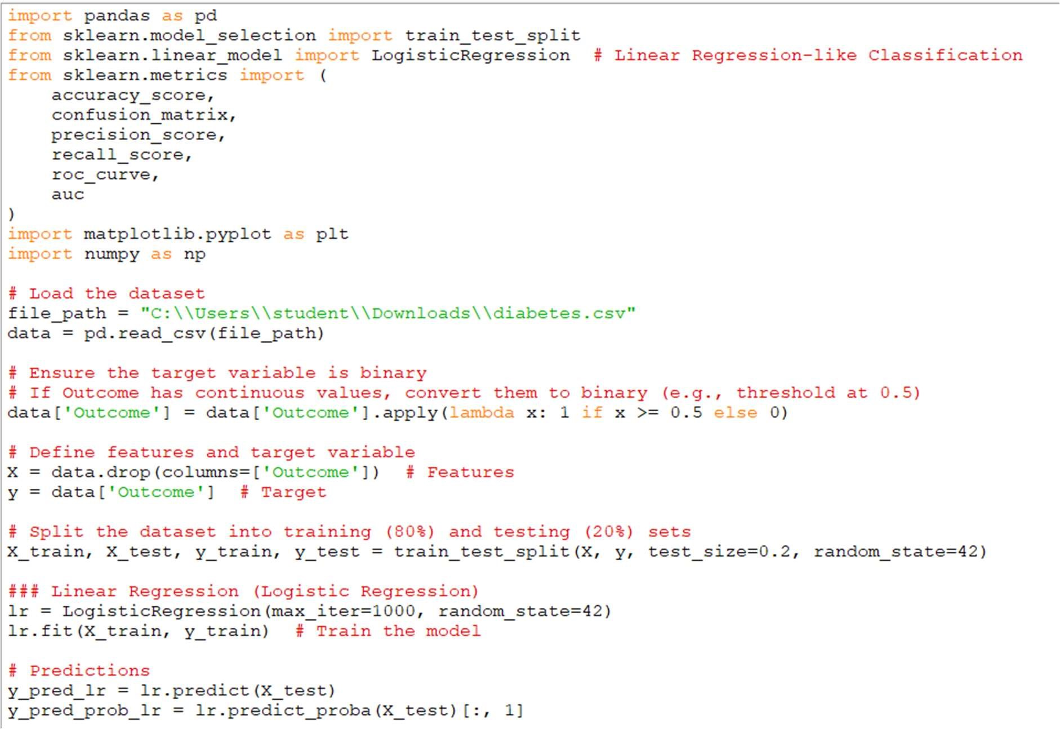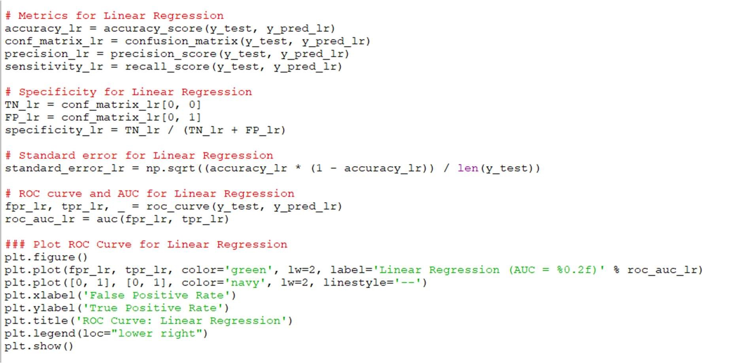

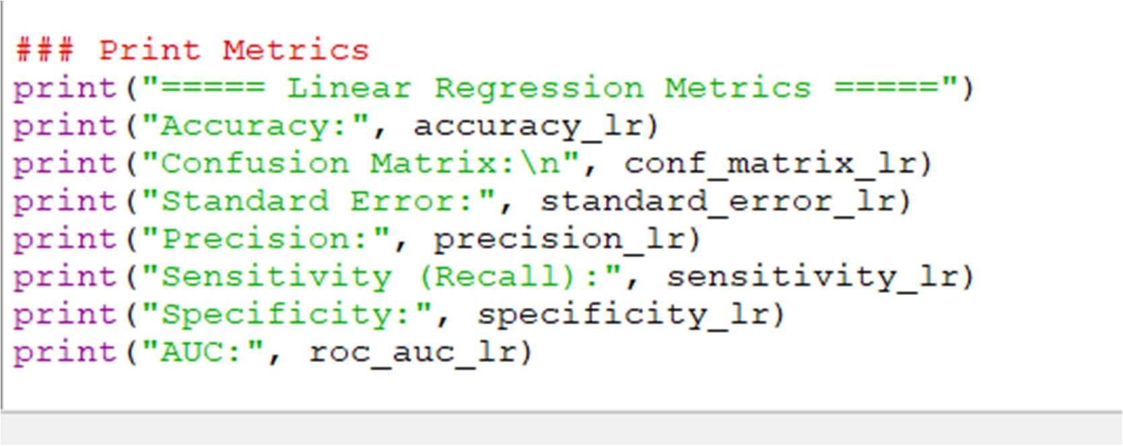

Output

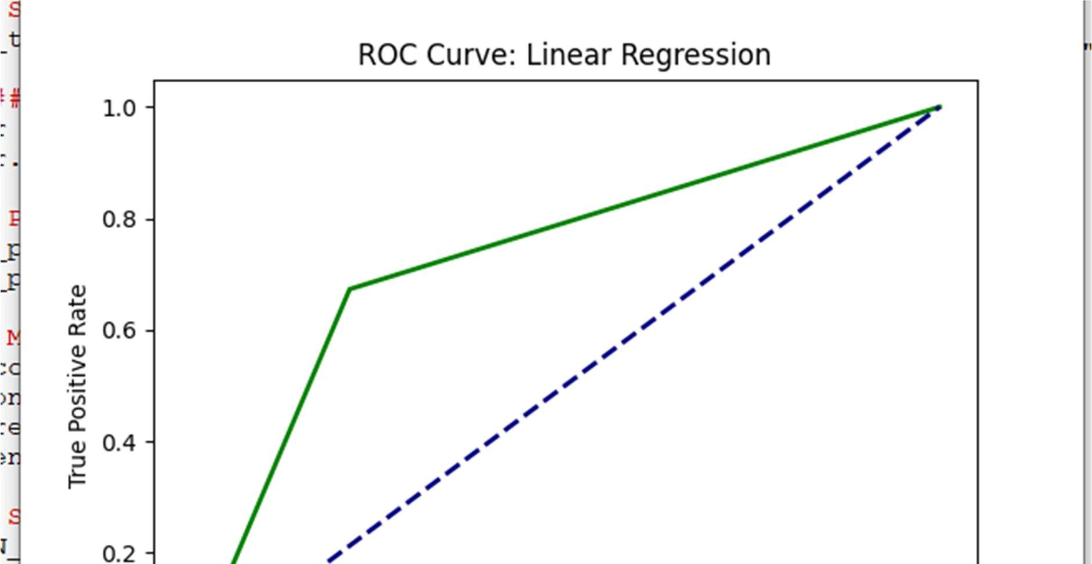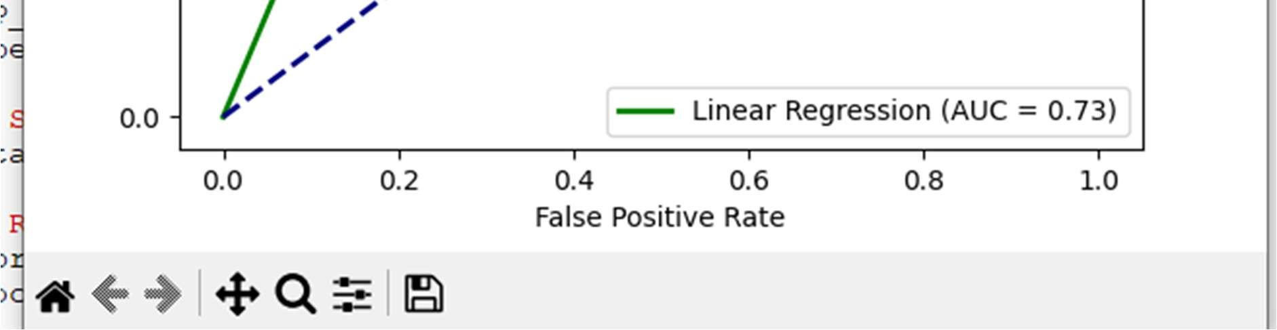

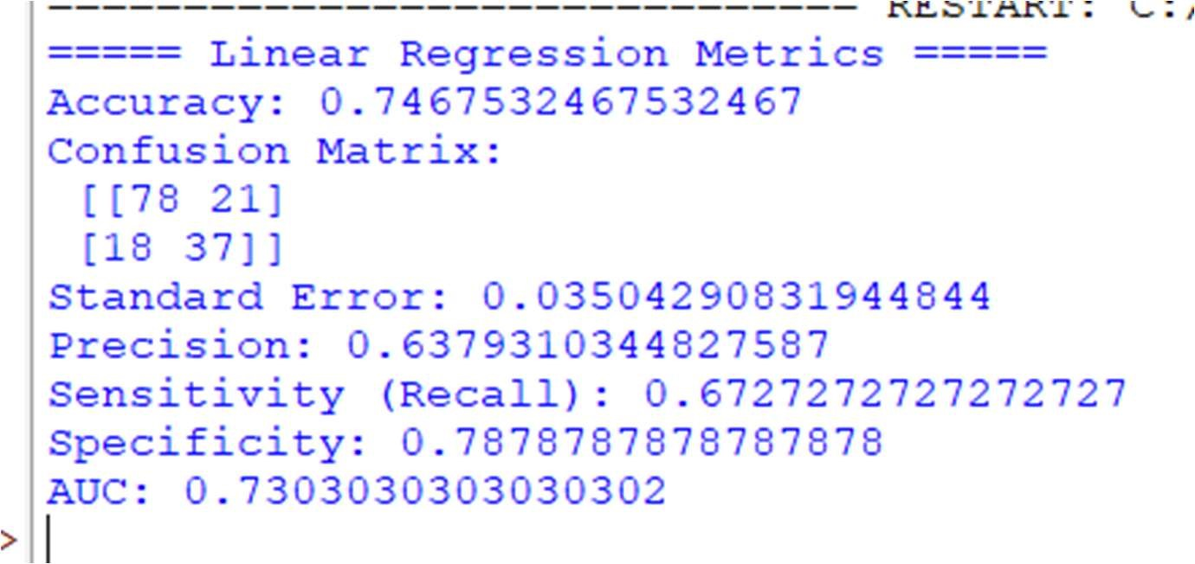

Summary of Model Performance Comparison:

* + Linear Regression Accuracy: 74.68%

Linear Regression performs well, achieving an accuracy of around 75%. It is a strong choice for classi ication tasks with linear relationships, even though it's typically used for regression.

* + Naive Bayes Accuracy: 74.46%

Naive Bayes is very close to Linear Regression in terms of accuracy (74.46%). It works well when the features are independent, and the small difference in accuracy suggests that the data may not have strong feature dependencies.

* + PCA Accuracy: 64.94%

PCA, being a dimensionality reduction technique rather than a model, performs the worst (64.94%). This lower accuracy is expected, as PCA is not directly used for classi ication; it is a preprocessing step to reduce feature dimensions before applying other models.

Conclusion:

* + Linear Regression and Naive Bayes show similar performance, with Linear Regression having a very slight edge.
  + PCA has the lowest accuracy, as it's a feature reduction method and not a predictive model on its own. It is useful as a preprocessing step but not for direct prediction.

**Practical 7**

**AIM : Improving Accuracy**

# Boosting

import pandas as pd from sklearn.model_selection import train_test_split from sklearn.ensemble import GradientBoostingClassifier from sklearn.metrics import accuracy_score, confusion_matrix, precision_score, recall_score, roc_curve, auc import matplotlib.pyplot as plt

# Read the data df = pd.read_csv('dataDecision.csv')

# Preprocessing: Convert categorical variables to dummy variables and map 'YES'/'NO' to 1/0 df = pd.get_dummies(df, columns=['GENDER', 'AGE'], drop_first=True) df['LUNG_CANCER'] = df['LUNG_CANCER'].map({'YES': 1, 'NO': 0})

# Split the data into features (X) and target (y)

X = df.drop(columns=['LUNG_CANCER']) y = df['LUNG_CANCER']

# Train-test split (80% training, 20% testing)

X_train, X_test, y_train, y_test = train_test_split(X, y, test_size=0.2, random_state=42)

# Train a Gradient Boosting model model = GradientBoostingClassifier(random_state=42) model.fit(X_train, y_train)

# Predictions and probabilities y_pred = model.predict(X_test)

y_prob = model.predict_proba(X_test)[:, 1]

# Calculate metrics accuracy = accuracy_score(y_test, y_pred) conf_matrix = confusion_matrix(y_test, y_pred) precision = precision_score(y_test, y_pred, zero_division=1) sensitivity = recall_score(y_test, y_pred) specificity = conf_matrix[0, 0] / (conf_matrix[0, 0] + conf_matrix[0, 1]) if (conf_matrix[0, 0] + conf_matrix[0, 1]) > 0 else 0 standard_error = (accuracy * (1 - accuracy)) / len(y_test)

# Print results

print("Accuracy:", accuracy) print("Confusion Matrix:\n", conf_matrix) print("Precision:", precision) print("Sensitivity (Recall):", sensitivity) print("Specificity:", specificity) print("Standard Error:", standard_error)

# Sample Input for prediction sample_input = {

'SMOKING': 2,

'YELLOW_FINGERS': 1,

'ANXIETY': 1,

'PEER_PRESSURE': 1,

'CHRONIC DISEASE': 1,

'FATIGUE': 2, 'ALLERGY': 1,

'WHEEZING': 1,

'ALCOHOL CONSUMING': 2,

'COUGHING': 2,

'SHORTNESS OF BREATH': 2,

'SWALLOWING DIFFICULTY': 1,

'CHEST PAIN': 2,

'GENDER_M': 1,

'AGE_Senior': 1,

'AGE_Youth': 0

}

# Convert sample input into DataFrame sample_df = pd.DataFrame([sample_input])

# Ensure all columns are present in the sample_df for col in X_train.columns: if col not in sample_df.columns:

sample_df[col] = 0

# Reorder the columns to match the training set sample_df = sample_df[X_train.columns]

# Make prediction sample_prediction = model.predict(sample_df) sample_prediction_label = 'YES' if sample_prediction[0] == 1 else 'NO' print("\nSample Input Prediction:", sample_prediction_label)

# Plot Feature Importance (Boosting models can provide feature importance) plt.figure(figsize=(10, 6))

plt.barh(X.columns, model.feature_importances_) plt.xlabel('Feature Importance') plt.title('Feature Importance from Gradient Boosting') plt.show()

# ROC Curve fpr, tpr, thresholds = roc_curve(y_test, y_prob) # False Positive Rate, True Positive Rate roc_auc = auc(fpr, tpr) # Compute AUC

# Plot ROC Curve plt.figure(figsize=(10, 6)) plt.plot(fpr, tpr, color='blue', lw=2, label=f'ROC curve (AUC = {roc_auc:.2f})') plt.plot([0, 1], [0, 1], color='gray', linestyle='--') # Diagonal line representing random model plt.xlim([0.0, 1.0]) plt.ylim([0.0, 1.05]) plt.xlabel('False Positive Rate') plt.ylabel('True Positive Rate') plt.title('Receiver Operating Characteristic (ROC) Curve') plt.legend(loc="lower right") plt.show()

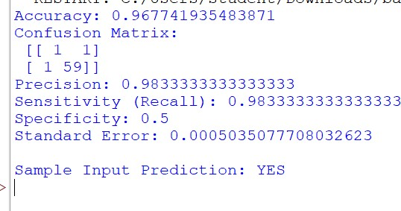

# Bootstrap

Source code:- import pandas as pd from sklearn.model_selection import train_test_split from sklearn.ensemble import RandomForestClassifier from sklearn.metrics import accuracy_score, confusion_matrix, precision_score, recall_score, roc_curve, auc import matplotlib.pyplot as plt

# Load dataset df = pd.read_csv(r'C:\Users\student\Downloads\dataDecision.csv')

# One-hot encode categorical variables and map 'LUNG_CANCER' to binary df = pd.get_dummies(df, columns=['GENDER', 'AGE'], drop_first=True) df['LUNG_CANCER'] = df['LUNG_CANCER'].map({'YES': 1, 'NO': 0})

# Split dataset into features (X) and target (y)

X = df.drop(columns=['LUNG_CANCER']) y = df['LUNG_CANCER']

# Split into training and test sets

X_train, X_test, y_train, y_test = train_test_split(X, y, test_size=0.2, random_state=42)

# Train a Random Forest Classifier model (Bootstrap technique) rf_model = RandomForestClassifier(n_estimators=100, random_state=42, bootstrap=True) rf_model.fit(X_train, y_train)

# Make predictions and calculate probabilities y_pred_rf = rf_model.predict(X_test)

y_prob_rf = rf_model.predict_proba(X_test)[:, 1]

# Calculate evaluation metrics for Random Forest model accuracy_rf = accuracy_score(y_test, y_pred_rf) conf_matrix_rf = confusion_matrix(y_test, y_pred_rf) precision_rf = precision_score(y_test, y_pred_rf, zero_division=1) sensitivity_rf = recall_score(y_test, y_pred_rf) specificity_rf = conf_matrix_rf[0, 0] / (conf_matrix_rf[0, 0] + conf_matrix_rf[0, 1]) if

(conf_matrix_rf[0, 0] + conf_matrix_rf[0, 1]) > 0 else 0 standard_error_rf = (accuracy_rf * (1 - accuracy_rf)) / len(y_test)

# Print results for Random Forest model print("Random Forest Model Evaluation:") print(f"Accuracy: {accuracy_rf}") print(f"Confusion Matrix:\n{conf_matrix_rf}") print(f"Precision: {precision_rf}") print(f"Sensitivity (Recall): {sensitivity_rf}") print(f"Specificity: {specificity_rf}") print(f"Standard Error: {standard_error_rf}")

# Sample input for prediction

sample_input = {

'SMOKING': 2,

'YELLOW_FINGERS': 1,

'ANXIETY': 1,

'PEER_PRESSURE': 1,

'CHRONIC DISEASE': 1,

'FATIGUE': 2,

'ALLERGY': 1,

'WHEEZING': 1,

'ALCOHOL CONSUMING': 2,

'COUGHING': 2,

'SHORTNESS OF BREATH': 2,

'SWALLOWING DIFFICULTY': 1,

'CHEST PAIN': 2,

'GENDER_M': 1,

'AGE_Senior': 1,

'AGE_Youth': 0

}

# Create DataFrame for sample input sample_df = pd.DataFrame([sample_input])

# Add missing columns from training data if not in sample input for col in X_train.columns: if col not in sample_df.columns:

sample_df[col] = 0

# Reorder columns to match training data sample_df = sample_df[X_train.columns]

# Make prediction for the sample input sample_prediction_rf = rf_model.predict(sample_df) sample_prediction_label_rf = 'YES' if sample_prediction_rf[0] == 1 else 'NO' print("\nSample Input Prediction (Random Forest):", sample_prediction_label_rf)

# Plot feature importances for Random Forest plt.figure(figsize=(10, 6)) plt.barh(X.columns, rf_model.feature_importances_) plt.xlabel('Feature Importance') plt.title('Feature Importances in Random Forest') plt.show()

# Calculate ROC curve and AUC for Random Forest model

fpr_rf, tpr_rf, thresholds = roc_curve(y_test, y_prob_rf) # False Positive Rate, True Positive Rate

roc_auc_rf = auc(fpr_rf, tpr_rf) # Compute AUC

# Plot ROC Curve for Random Forest model plt.figure(figsize=(10, 6)) plt.plot(fpr_rf, tpr_rf, color='green', lw=2, label=f'Random Forest (AUC = {roc_auc_rf:.2f})') plt.plot([0, 1], [0, 1], color='gray', linestyle='--') # Diagonal line representing random model plt.xlim([0.0, 1.0]) plt.ylim([0.0, 1.05]) plt.xlabel('False Positive Rate') plt.ylabel('True Positive Rate') plt.title('Receiver Operating Characteristic (ROC) Curve for Random Forest') plt.legend(loc="lower right") plt.show()

Output : -

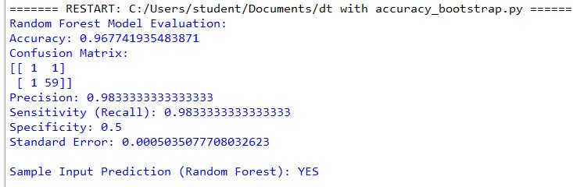

–All combined code

import pandas as pd import numpy as np import seaborn as sns import matplotlib.pyplot as plt from sklearn.model_selection import train_test_split, cross_val_score, KFold from sklearn.tree import DecisionTreeClassifier from sklearn.naive_bayes import GaussianNB from sklearn.linear_model import LinearRegression from sklearn.decomposition import PCA

from sklearn.metrics import accuracy_score, confusion_matrix, precision_score, recall_score, roc_curve, auc from sklearn.preprocessing import StandardScaler, MinMaxScaler from sklearn.ensemble import BaggingClassifier, AdaBoostClassifier from sklearn.utils import resample from scipy.stats import chi2_contingency

# Load data df = pd.read_csv(r'C:\Users\student\Downloads\dataDecision.csv')

# Data Cleaning df = df.dropna() # Drop missing values df = pd.get_dummies(df, columns=['GENDER', 'AGE'], drop_first=True) df['LUNG_CANCER'] = df['LUNG_CANCER'].map({'YES': 1, 'NO': 0})

# Exploratory Data Analysis print("Data Head:") print(df.head())

# Correlation Heatmap plt.figure(figsize=(10, 6)) sns.heatmap(df.corr(), annot=True, cmap='coolwarm', fmt=".2f") plt.title("Correlation Heatmap") plt.show()

# # Chi-Square Test for Categorical Features

# cat_cols = ['GENDER', 'AGE',] # Replace with actual column names # for col in cat_cols:

# contingency_table = pd.crosstab(df[col], df['LUNG_CANCER'])

# chi2, p, dof, expected = chi2_contingency(contingency_table)

# print(f"Chi-Square Test for {col}:")

# print(f" Chi2: {chi2:.3f}, p-value: {p:.3f}")

# Feature Selection and Target Variable

X = df.drop(columns=['LUNG_CANCER']) y = df['LUNG_CANCER']

# Scaling standard_scaler = StandardScaler() minmax_scaler = MinMaxScaler()

X_std = standard_scaler.fit_transform(X)

X_mm = minmax_scaler.fit_transform(X)

# Train/test split

X_train_std, X_test_std, y_train, y_test = train_test_split(X_std, y, test_size=0.2, random_state=69)

X_train_mm, X_test_mm, _, _ = train_test_split(X_mm, y, test_size=0.2, random_state=69)

# Simple PCA

pca = PCA(n_components=5)

X_train_std_pca = pca.fit_transform(X_train_std)

X_test_std_pca = pca.transform(X_test_std)

X_train_mm_pca = pca.fit_transform(X_train_mm)

X_test_mm_pca = pca.transform(X_test_mm)

# Evaluation function def evaluate_model(y_true, y_pred, y_prob): acc = accuracy_score(y_true, y_pred) cm = confusion_matrix(y_true, y_pred) prec = precision_score(y_true, y_pred, zero_division=1) sens = recall_score(y_true, y_pred) spec = cm[0, 0] / (cm[0, 0] + cm[0, 1]) if (cm[0, 0] + cm[0, 1]) else 0 se = (acc * (1 - acc)) / len(y_true) fpr, tpr, _ = roc_curve(y_true, y_prob) model_auc = auc(fpr, tpr) return acc, cm, prec, sens, spec, se, model_auc

# Models dt_bag = BaggingClassifier(DecisionTreeClassifier(random_state=69), n_estimators=50, random_state=69) nb_bag = BaggingClassifier(GaussianNB(), n_estimators=50, random_state=69) lr = LinearRegression()

# Boosting model dt_ada = AdaBoostClassifier(DecisionTreeClassifier(random_state=69), n_estimators=50, random_state=69)

# Bootstrap Sampling

X_bootstrap, y_bootstrap = resample(X, y, replace=True, random_state=69)

# Cross-validation setup cv = KFold(n_splits=5, shuffle=True, random_state=69) def cross_val_accuracy(model, X_data, y_data):

scores = cross_val_score(model, X_data, y_data, cv=cv, scoring='accuracy') return np.mean(scores)

# Train and evaluate (Standardized) dt_bag.fit(X_train_std, y_train) nb_bag.fit(X_train_std, y_train) lr.fit(X_train_std, y_train) dt_ada.fit(X_train_std, y_train)

pred_dt_bag = dt_bag.predict(X_test_std) pred_nb_bag = nb_bag.predict(X_test_std) pred_lr = lr.predict(X_test_std) pred_lr_bin = (pred_lr > 0.5).astype(int) pred_dt_ada = dt_ada.predict(X_test_std)

res_std = {

'Bagging DT': evaluate_model(y_test, pred_dt_bag, dt_bag.predict_proba(X_test_std)[:, 1]),

'Bagging NB': evaluate_model(y_test, pred_nb_bag, nb_bag.predict_proba(X_test_std)[:,

1]),

'Linear Regression': evaluate_model(y_test, pred_lr_bin, pred_lr),

'AdaBoost DT': evaluate_model(y_test, pred_dt_ada, dt_ada.predict_proba(X_test_std)[:,

1])

}

# Cross-validation accuracy comparison (Bagging DT example) dt_cv_std = cross_val_accuracy(dt_bag, X_std, y)

# Print results print("Model Evaluation Results (Standardized)\n") for model_name in res_std: acc_std, cm_std, prec_std, sens_std, spec_std, se_std, auc_std = res_std[model_name] print(f"{model_name}:") print(f" Accuracy: {acc_std:.3f}") print(f" Confusion Matrix:\n{cm_std}") print(f" Precision: {prec_std:.3f}") print(f" Sensitivity: {sens_std:.3f}") print(f" Specificity: {spec_std:.3f}") print(f" Standard Error: {se_std:.4f}") print(f" AUC: {auc_std:.3f}\n")

print("Cross-Validation Accuracy (Bagging DT example):") print(f" Standard Scaler: {dt_cv_std:.3f}")

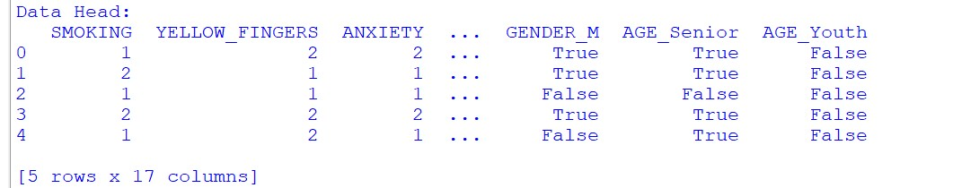

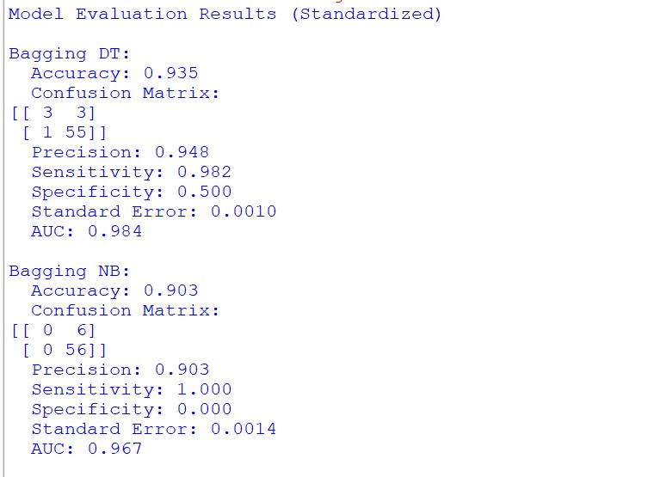

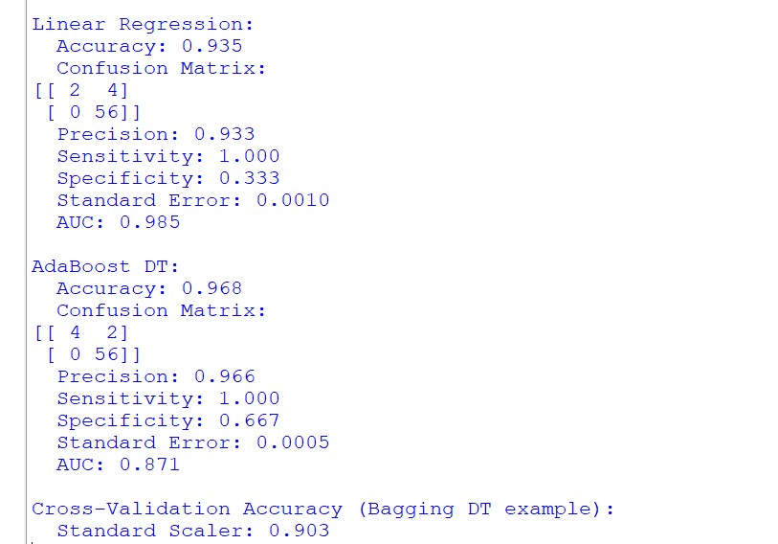

**Practical 8**

**AIM : Clustering**

# Source Code

import pandas as pd import numpy as np import matplotlib.pyplot as plt from sklearn.cluster import KMeans, AgglomerativeClustering from sklearn.metrics import silhouette_score from scipy.cluster.hierarchy import dendrogram, linkage from sklearn.preprocessing import StandardScaler from sklearn.decomposition import PCA # Load the dataset diabetes = pd.read_csv("C:/diabetes.csv") # Explore the dataset print(diabetes.describe()) print(diabetes.columns) # Prepare data for clustering new_data = diabetes.drop(columns=['Outcome']) print(new_data.head()) # K-Means clustering kmeans = KMeans(n_clusters=3, random_state=42) kmeans.fit(new_data) diabetes['kmeans_cluster'] = kmeans.labels_ # Elbow method to find optimal k wss = [] for k in range(1, 16): kmeans = KMeans(n_clusters=k, random_state=42) kmeans.fit(new_data) wss.append(kmeans.inertia_) plt.plot(range(1, 16), wss, marker='o') plt.xlabel('Number of clusters k') plt.ylabel('Total within-clusters sum of square') plt.show()

# Standardize the data scaler = StandardScaler() X_std = scaler.fit_transform(new_data)

# Reduce dimensions for visualization (you can skip this step if you have fewer features) pca = PCA(n_components=2) X_pca = pca.fit_transform(X_std)

# Visualize the clusters plt.scatter(X_pca[:, 0], X_pca[:, 1], c=kmeans.labels_, cmap='viridis') plt.title('K-means Clustering') plt.xlabel('Principal Component 1') plt.ylabel('Principal Component 2') plt.show() # Silhouette Score for K-Means silhouette_avg = silhouette_score(new_data, diabetes['kmeans_cluster']) print("Mean Silhouette Width for K-Means Clustering:", silhouette_avg) # Hierarchical clustering linkage_matrix = linkage(new_data, method='ward') dendrogram(linkage_matrix) plt.title('Hierarchical Clustering Dendrogram') plt.show() # Agglomerative clustering agglomerative = AgglomerativeClustering(n_clusters=3) diabetes['hierarchical_cluster'] = agglomerative.fit_predict(new_data) # Plot Hierarchical clusters plt.scatter(new_data['Pregnancies'], new_data['Glucose'], c=diabetes['hierarchical_cluster'], cmap='viridis', alpha=0.6, s=50) plt.xlabel('Pregnancies') plt.ylabel('Glucose') plt.title('Hierarchical Clustering') plt.show() # Silhouette Score for Hierarchical Clustering silhouette_avg_hierarchical = silhouette_score(new_data, diabetes['hierarchical_cluster']) print("Mean Silhouette Width for Hierarchical Clustering:", silhouette_avg_hierarchical)

# Output

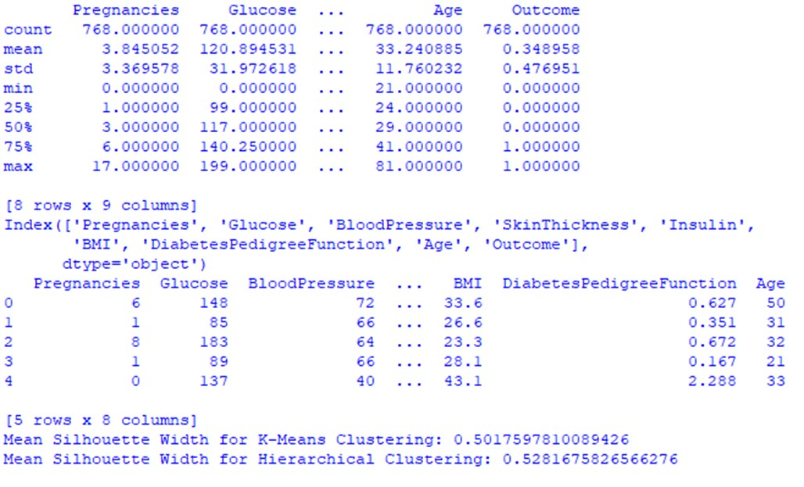

# Plots

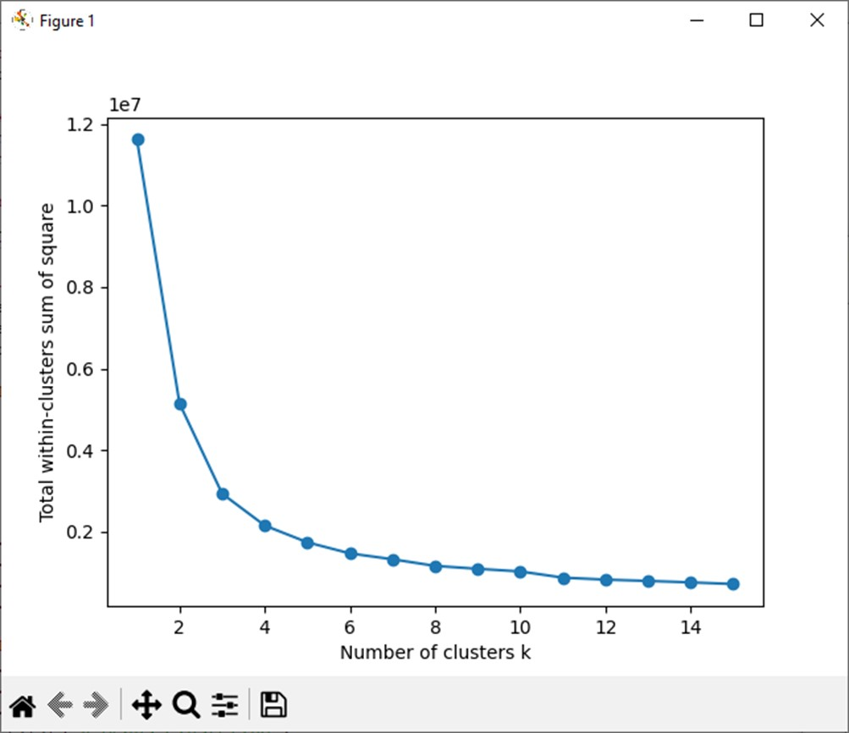

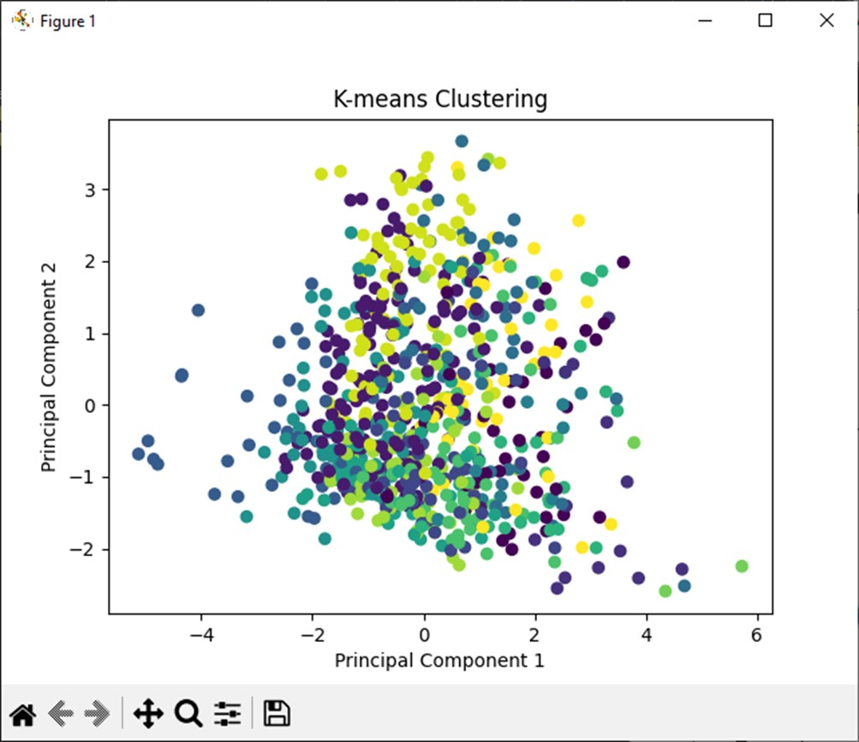

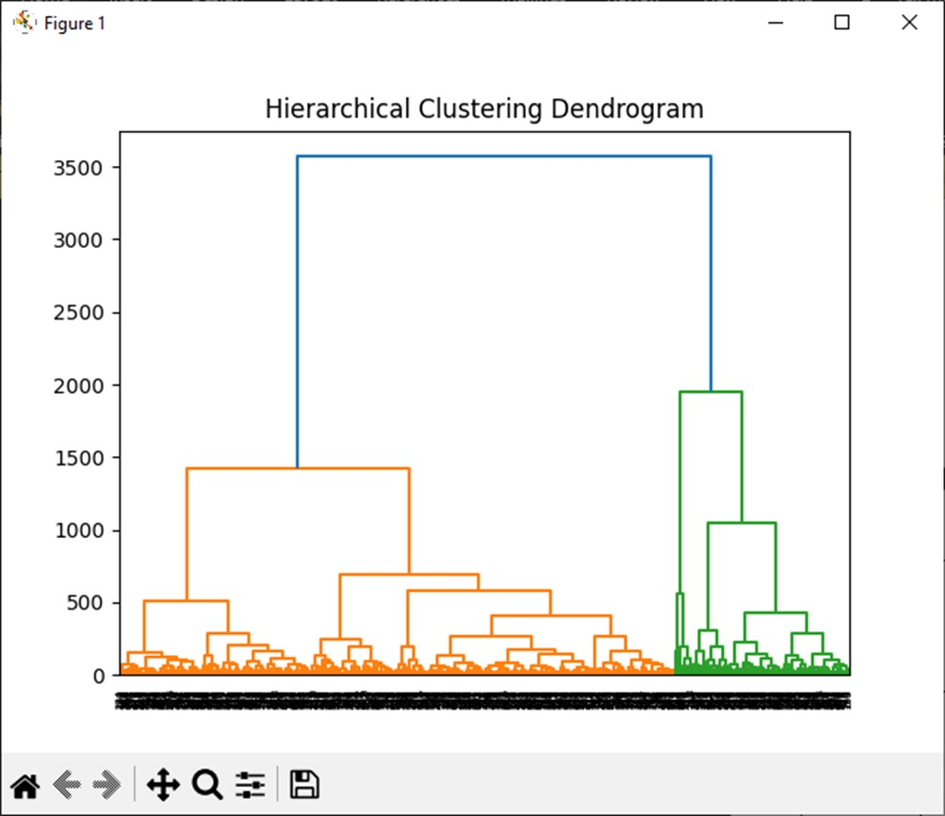

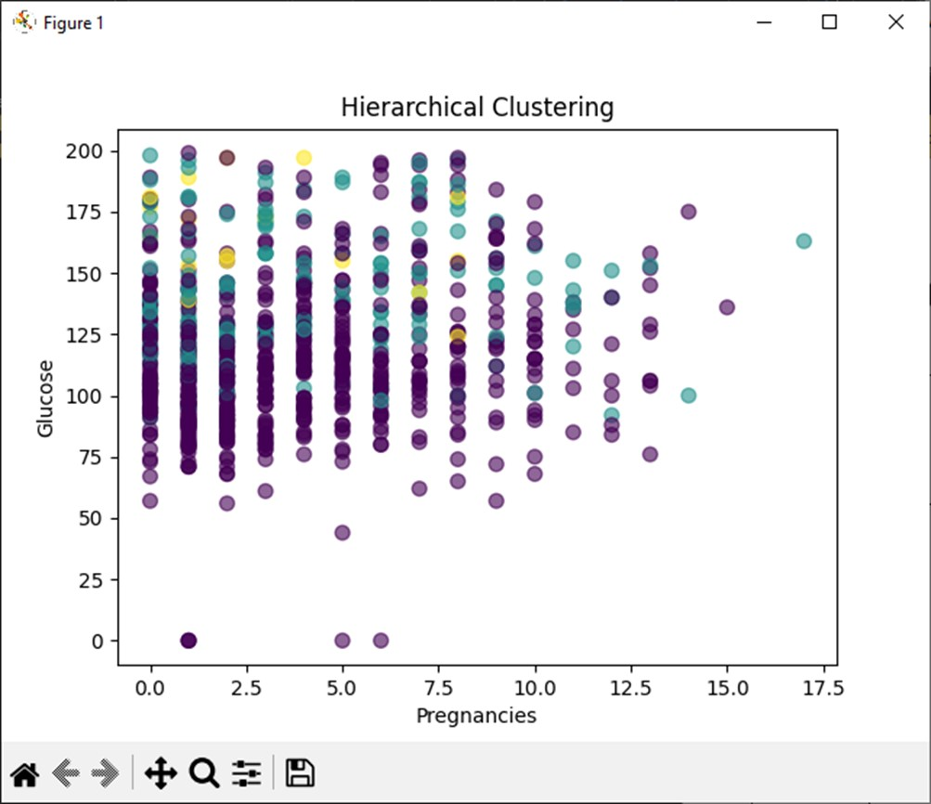

Python

Source code :- import pandas as pd import numpy as np import matplotlib.pyplot as plt from sklearn.cluster import KMeans from sklearn.preprocessing import StandardScaler from scipy.cluster.hierarchy import linkage, dendrogram from sklearn.cluster import AgglomerativeClustering from sklearn.metrics import silhouette_samples, silhouette_score import seaborn as sb

data=pd.read_csv("C:/Users/student/Desktop/samiksha/diabetes.csv")

print(data.head()) print(data.columns) x=data.drop('Outcome',axis=1) print(x.shape)

kmeans = KMeans(n_clusters=3) kmeans.fit(x) cluster_labels_1=kmeans.labels_ print(cluster_labels_1)

cluster_centers = kmeans.cluster_centers_ print(cluster_centers)

cluster_num=[]

####ELBOW METHOD########

for k in range(1,15): kmeans = KMeans(n_clusters=k) kmeans.fit(x) cluster_num.append(kmeans.inertia_) clus_centre=kmeans.cluster_centers_

plt.plot(range(1, 15), cluster_num) plt.title('Elbow Method') plt.xlabel('Number of Clusters (k)') plt.ylabel('Within-Cluster Sum of Squares') plt.show()

####kmeans clustering dendogram### Z = linkage(clus_centre, method='ward') plt.figure(figsize=(10, 5))

dendrogram(Z) plt.title('Dendrogram of K-means Clustering') plt.xlabel('Cluster Index') plt.ylabel('Distance') plt.show()

#Agglomerative heirarchical clustering ## hierarchical_cluster = AgglomerativeClustering(n_clusters=2, linkage='ward') cluster_labels = hierarchical_cluster.fit_predict(x) print(cluster_labels)

linkage_matrix = linkage(x, method='ward') plt.figure(figsize=(12, 6)) dendrogram(linkage_matrix) plt.title('Dendrogram') plt.xlabel('Samples') plt.ylabel('Distance') plt.show()

##Silhoutte coefficient hierachichal##

sample_silhouette_values = silhouette_samples(x, cluster_labels) silhouette_avg = silhouette_score(x, cluster_labels) print("Silhouette Scores:", sample_silhouette_values) print("Average Silhouette Score:", silhouette_avg)

##Silhoutte coefficient kmeans## sample_silhouette_values = silhouette_samples(x, cluster_labels_1) silhouette_avg = silhouette_score(x, cluster_labels_1) print("Silhouette Scores (kmeans):", sample_silhouette_values) print("Average Silhouette Score (kmeans):", silhouette_avg) ###scatterplot### df = pd.DataFrame(x) features =['Pregnancies', 'Glucose', 'BloodPressure', 'SkinThickness', 'Insulin', 'BMI', 'DiabetesPedigreeFunction', 'Age', 'Outcome']

plt.figure(figsize=(9,6))

sb.scatterplot(x='Pregnancies',y='Glucose',hue=cluster_labels_1,palette = "Dark2", legend = False,data=x) sb.scatterplot(x = cluster_centers[:, 0], y = cluster_centers[:, 1], color = "black", marker = "x", s = 200) plt.ylabel('Glucose') plt.xlabel('Pregnancies') plt.title('Cluster Plot') plt.show()

Output :-

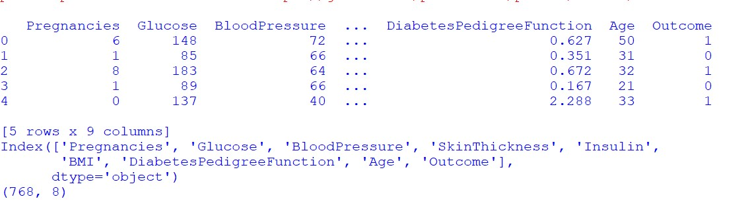

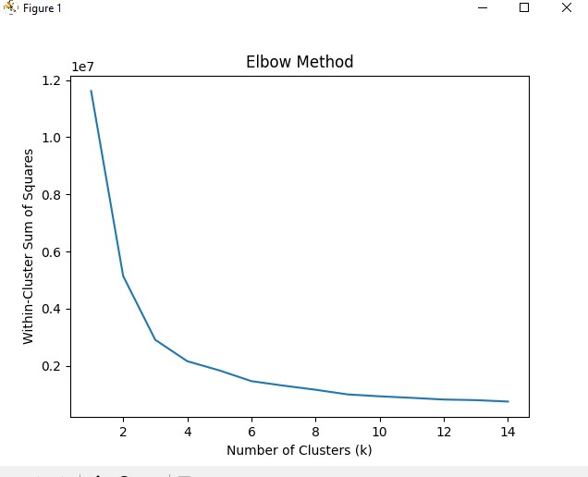

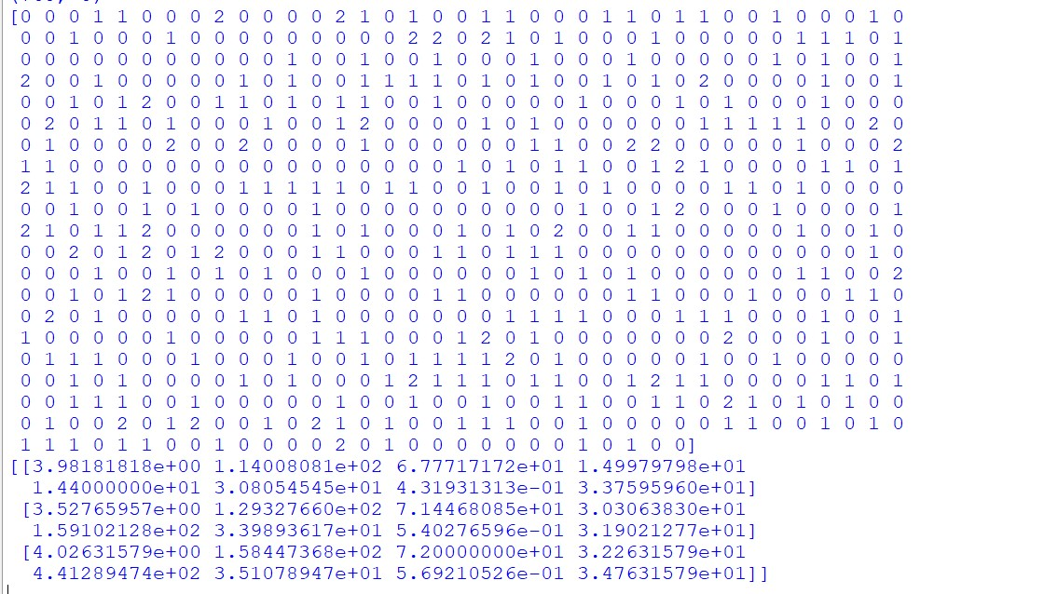

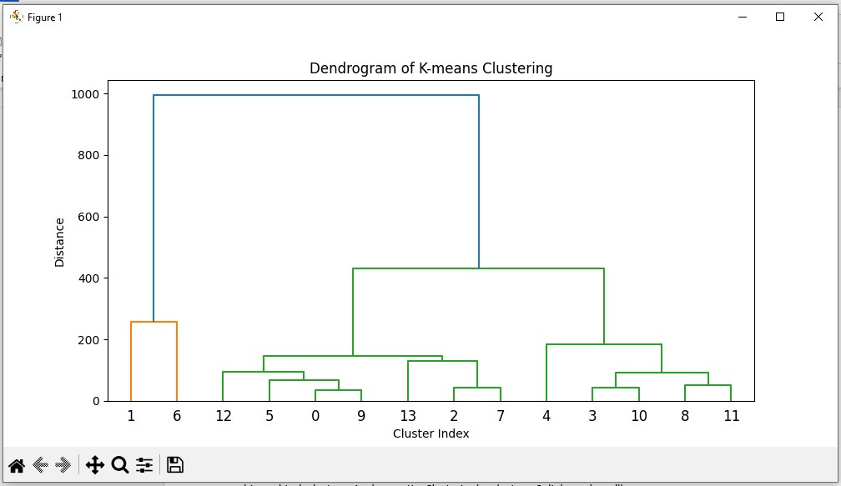

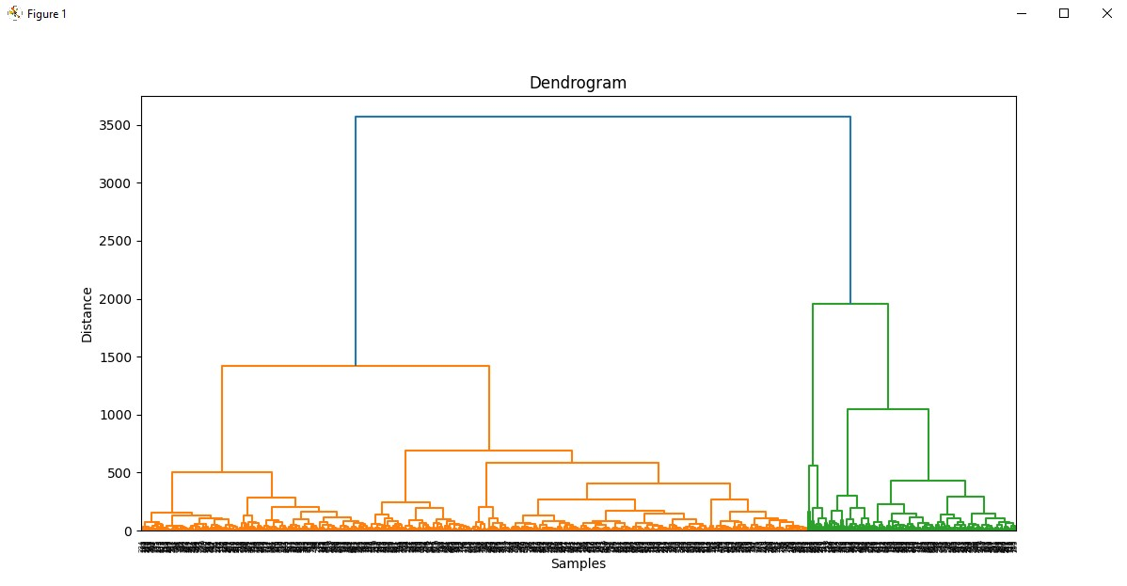

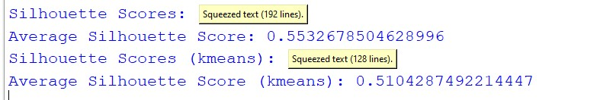

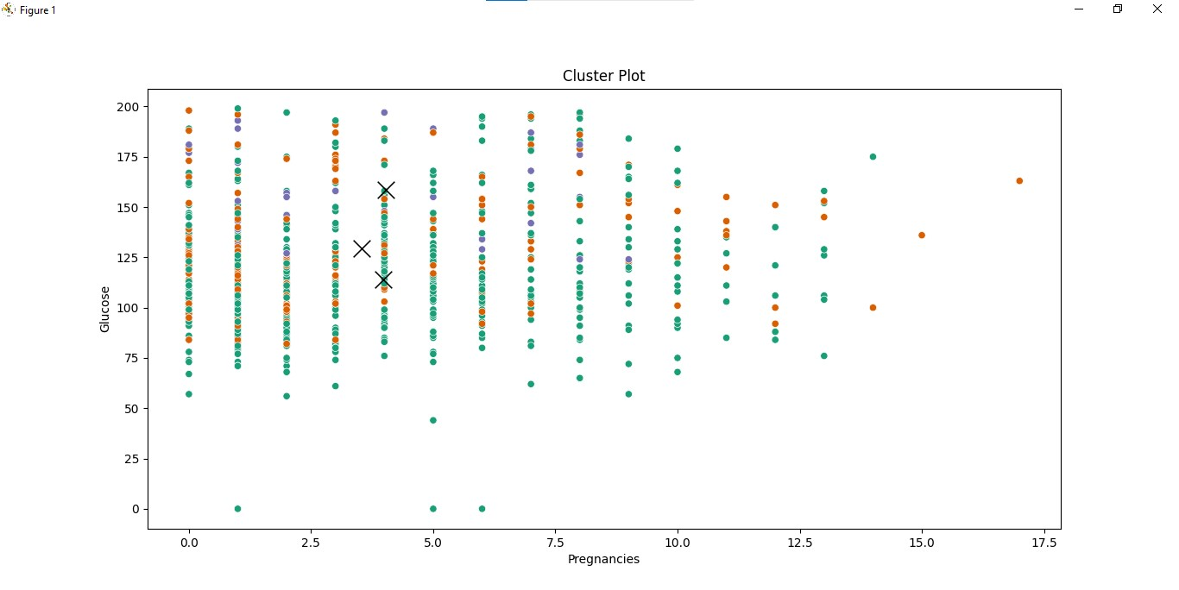

**Practical 9**

**AIM : Association**

1. apriori:-

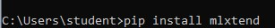

Source code :- import pandas as pd import seaborn as sns import matplotlib.pyplot as plt from mlxtend.preprocessing import TransactionEncoder from mlxtend.frequent_patterns import apriori, association_rules import csv import matplotlib.colors as mcolors

# Load the CSV file with irregular rows file_path = "C:/ty/DS/groceries - groceries.csv" transactions = [] with open(file_path, "r") as file: reader = csv.reader(file) for row in reader: transactions.append([item.strip() for item in row if item.strip() != ""]) print("Sample Transactions:\n", transactions[:10])

# Perform Transaction Encoding te = TransactionEncoder() te_ary = te.fit(transactions).transform(transactions) df = pd.DataFrame(te_ary, columns=te.columns_) print("Transaction DataFrame Head:\n", df.head(5)) print("DataFrame Shape:", df.shape)

# Find Frequent Itemsets (Removed support_only argument) frequent_itemsets = apriori(df, min_support=0.01, use_colnames=True) print("Frequent Itemsets:\n", frequent_itemsets)

# Count of Frequent Itemsets print("Number of Frequent Itemsets:", frequent_itemsets['itemsets'].count())

# Dynamically generate enough distinct colors for the palette

colors = list(mcolors.TABLEAU_COLORS.values()) + list(mcolors.CSS4_COLORS.values()) colors = colors[:15] # Use 15 distinct colors for the top 15 itemsets

# Plot the top 15 itemsets by support plt.figure(figsize=(12, 6)) sns.barplot( x=frequent_itemsets.nlargest(n=15, columns='support')['itemsets'].astype(str), y=frequent_itemsets.nlargest(n=15, columns='support')['support'], palette=colors, hue=frequent_itemsets.nlargest(n=15, columns='support')['itemsets'].astype(str), dodge=False

)

plt.legend([], [], frameon=False) # Remove the redundant legend plt.xlabel("Itemsets") plt.ylabel("Support") plt.title("Top 15 Frequent Itemsets by Support") plt.xticks(rotation=90) plt.show()

# Calculate the number of itemsets for older versions of mlxtend num_itemsets = len(frequent_itemsets)

# Generate Association Rules with 'num_itemsets' for older versions rules = association_rules(frequent_itemsets, num_itemsets=num_itemsets, metric="lift", min_threshold=1) print("Association Rules (Metric: Lift):\n", rules)

# Add Antecedent and Consequent Lengths rules["antecedent_len"] = rules["antecedents"].apply(lambda x: len(x)) rules["consequent_len"] = rules["consequents"].apply(lambda x: len(x)) print("Rules with Antecedent/Consequent Lengths:\n", rules)

# Example Filtering Rules filtered_rules = rules[(rules['antecedent_len'] >= 2) & (rules['confidence'] > 0.3) &

(rules['lift'] > 1)] print("Filtered Rules with Conditions:\n", filtered_rules)

# Rules with Consequent Length >= 2 filtered_rules_conseq = rules[

(rules['consequent_len'] >= 2) &

(rules['lift'] > 1)

].sort_values(by=['lift', 'confidence'], ascending=False) print("Filtered Rules with Consequent Length >= 2:\n", filtered_rules_conseq) # Accuracy Metrics print("---------------------ACCURACY METRICS-------------------------------") rules_lift = association_rules(frequent_itemsets, num_itemsets=num_itemsets, metric="lift", min_threshold=1) print("Rules (Metric: Lift):\n", rules_lift)

rules_confidence = association_rules(frequent_itemsets, num_itemsets=num_itemsets, metric="confidence", min_threshold=0.5) print("Rules (Metric: Confidence):\n", rules_confidence)

rules_leverage = association_rules(frequent_itemsets, num_itemsets=num_itemsets, metric="leverage", min_threshold=0.01) print("Rules (Metric: Leverage):\n", rules_leverage)

rules_conviction = association_rules(frequent_itemsets, num_itemsets=num_itemsets, metric="conviction", min_threshold=1)

print("Rules (Metric: Conviction):\n", rules_conviction)

**Output :-**

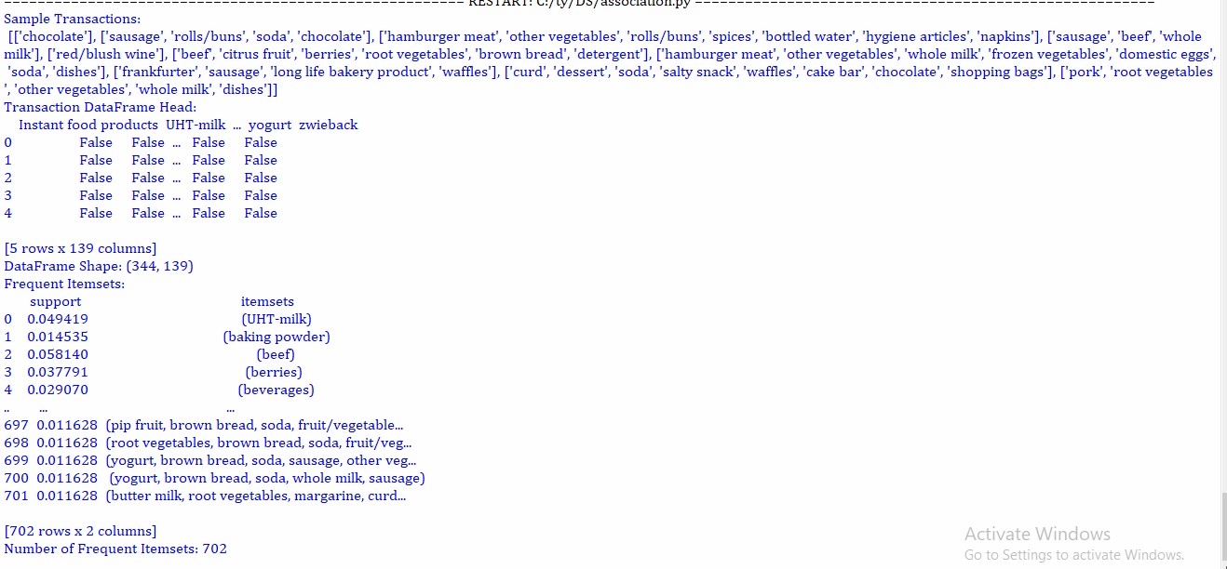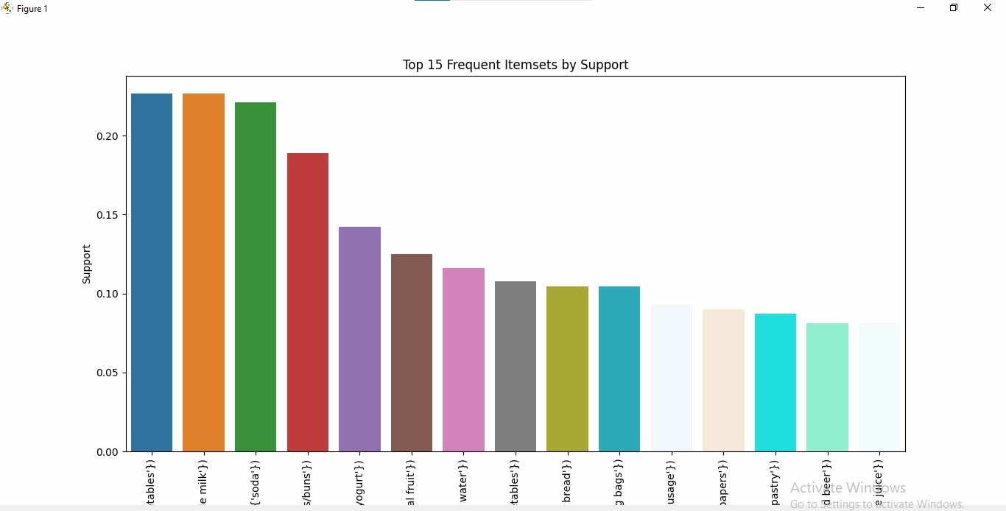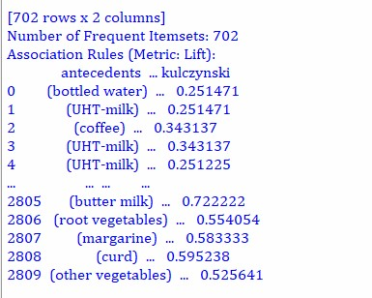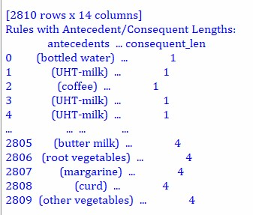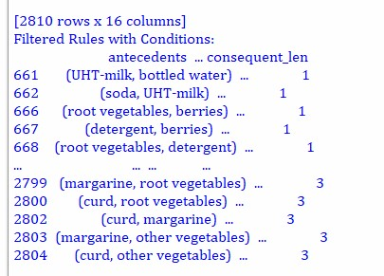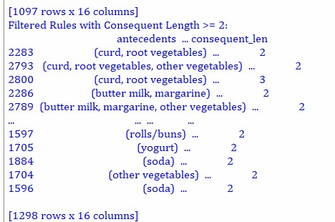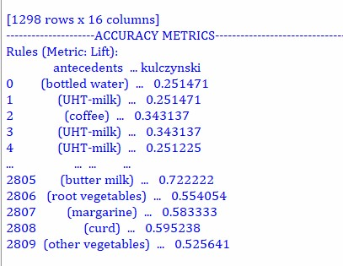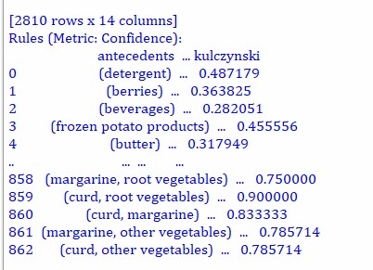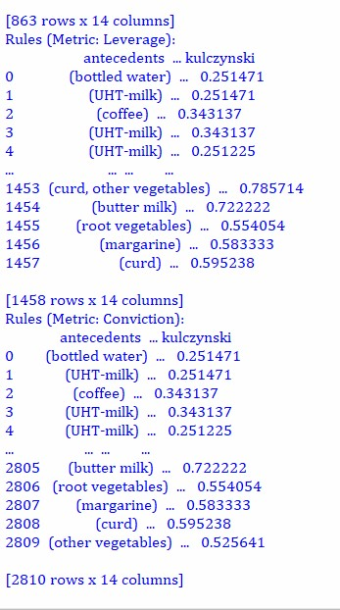

# FP Tree



**Source code:**

import pyfpgrowth

##transactions = [[1, 2, 5],

## [2, 4],

## [2, 3],

## [1, 2, 4],

## [1, 3],

## [2, 3],

## [1, 3],

## [1, 2, 3, 5],

## [1, 2, 3]]

import csv

with open('C:/ty/DS/Groceries_dataset.csv', encoding="utf8", newline='') as f:

reader = csv.reader(f) data = list(reader)

for i in range(len(data)):

if '' in data[i]:

data[i] = [x for x in data[i] if x]

data.pop(0)

print("some records",data[0:10])

patterns = pyfpgrowth.find_frequent_patterns(data, 2) print("pattern",patterns) print()

rules = pyfpgrowth.generate_association_rules(patterns, 0.7) print("rules output",rules)**Output:**

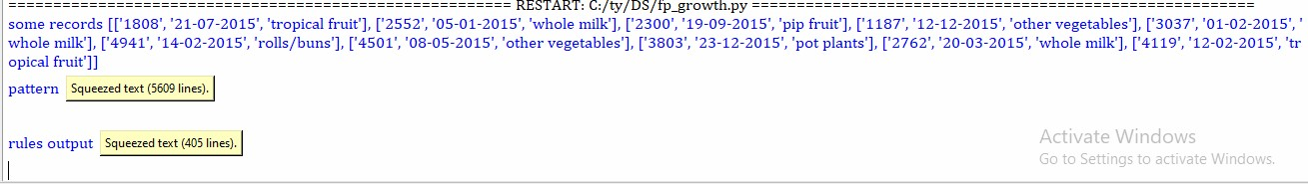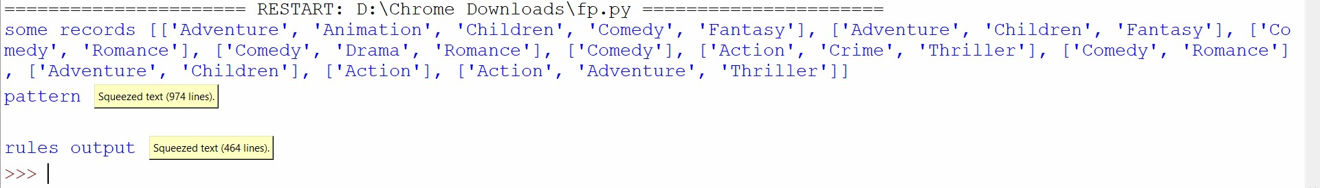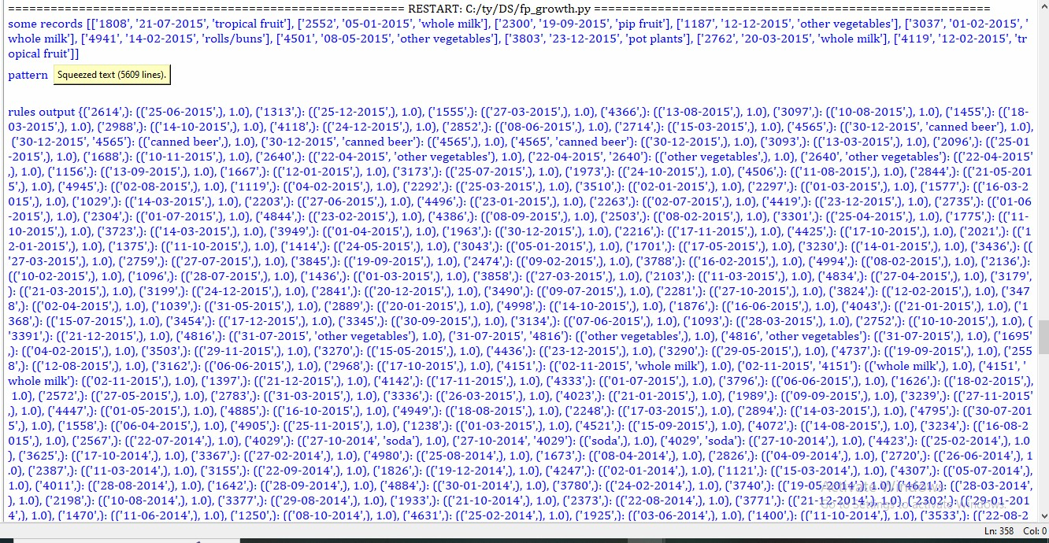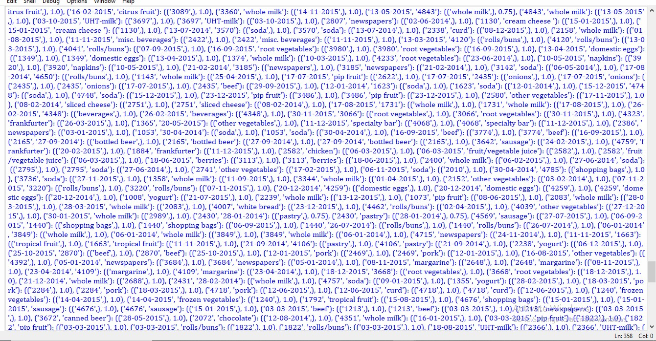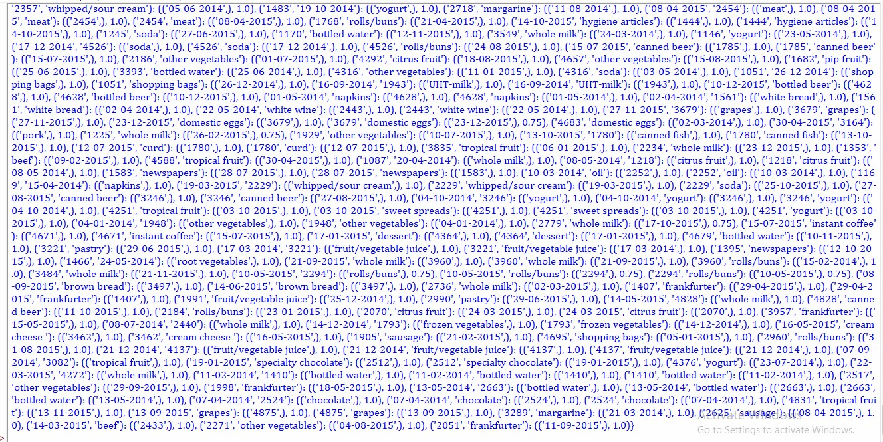

Here the patterns are generated using the fp tree algorithm. The patterns, have a format as



The patterns are then passed to the rules function which creates rules as follows:



Antecedent: '3810', 'yogurt'

Consequent: ['21-07-2014']

Confidence: 1.0

Interpretation: If a customer purchased item '3810' and yogurt, it is 100% certain that this transaction occurred on '21-07-2014'.

Here, the rules are interpreted as follows: if a person watches movies made for IMAX threaters, and genres like mystery, Sci-Fi then the person will watch a movie of Thriller genre. The Probability here i.e. 1.0 is the probability i.e. If occurs 100 times then thriller occurs all



the times with this set because its probability is 100%.

**Practical 10**

**AIM : MongoDB**

1. Extract mongodb zip file in C:\ drive



1. create folder data in C:\
2. Create folder db in C:\data\db

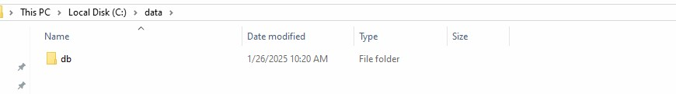

1. Goto C:\mongodb\bin and click on mongod.exe and keep server running

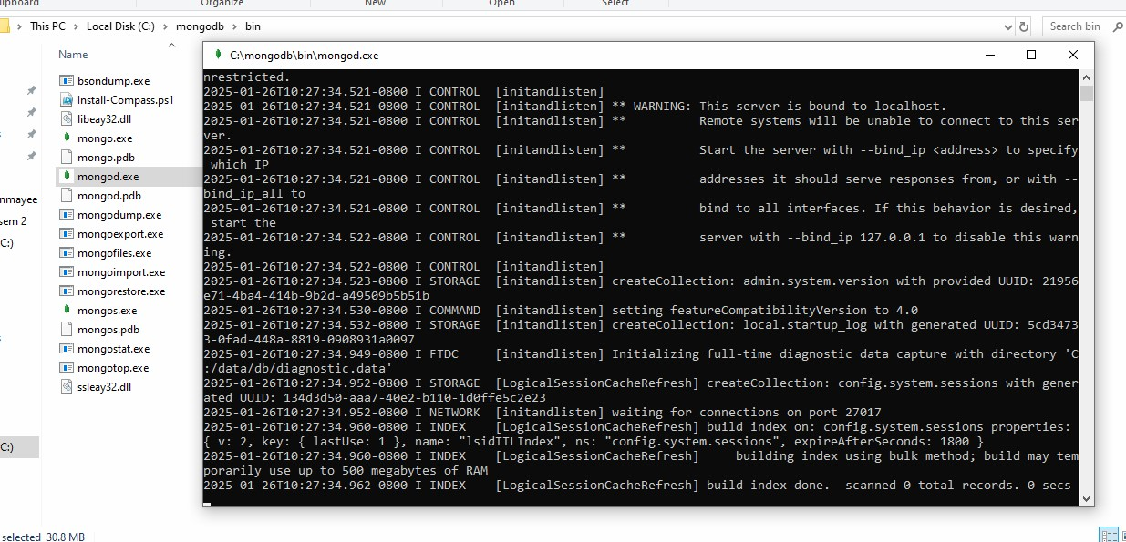

1. Click on mongo.exe



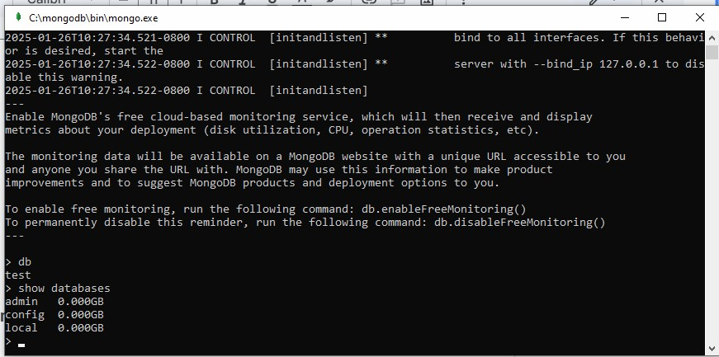

Refer the links to create database insert records and query.

https://www.tutorialspoint.com/mongodb/mongodb_create_database.htm https://www.tutorialspoint.com/mongodb/mongodb_drop_database.htm

# Create Database in MongoDB

Once you are in the MongoDB shell, create the database in MongoDB by typing this command:

use

database_name

For example: create a database “books”:

use books

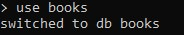

**Note:** If the database name you mentioned is already present then this command will connect you to the database. However if the database doesn’t exist then this will create the database with the given name and connect you to it.

At any point if you want to check the currently connected database just type the command **db**. This command will show the database name to which you are currently connected. This is really helpful command when you are working with several databases so that before creating a collection or inserting a document in database, you may want to ensure that you are in the right database.

>db books

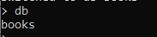

To list down all the databases, use the command **show dbs**. This command lists down all the databases and their size on the disk.

> show dbs admin 0.000GB config 0.000GB local 0.000GB

As you can see that the database “books” that we have created is not present in the list of all the databases. This is because a database is not created until you save a document in it.

Now let us create a collection **user** and insert a document in it.

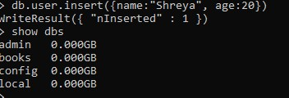

> db.user.insert({name:"Shreya", age:20})

WriteResult({ "nInserted" : 1 })

> show dbs admin 0.000GB books 0.000GB config 0.000GB local 0.000GB

>

# Drop Database in MongoDB

We use db.dropDatabase() command to delete a database. You should be very careful when deleting a database as this will remove all the data inside that database, including collections and documents stored in the database.

# MongoDB Drop Database

The syntax to drop a Database is:

db.dropDatabase()

We do not specify any database name in this command, because this command deletes the

currently selected database. Lets see the steps to drop a database in MongoDB.

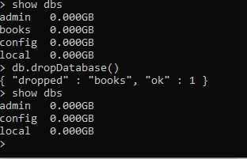

1

. See the list of databases using

**show dbs**

command.

>

show dbs

admin 0.000GB

books 0.000GB

config 0.000GB

local 0.000GB

2

. Switch to the database that needs to be dropped by typing this command.

>

use books

switched to db books

Note: Change the database name in the above command, from

books

to the database that needs

to be deleted.

3. Now, the currently selected database is books so the command db.dropDatabase() would delete this database.

> db.dropDatabase()

{ "dropped" : "books", "ok" : 1 }

The command executed successfully and showing the operation “dropped” and status “ok” which means that the database is dropped.

> use books switched to db books

> db.dropDatabase()

{ "dropped" : "books", "ok" : 1 }

>

show dbs

admin 0.000GB

config 0.000GB

local 0.000GB

# Create Collection in MongoDB

We know that the data in MongoDB is stored in form of documents. These documents are stored in Collection and Collection is stored in Database.

# Method 1: Creating the Collection in MongoDB on the fly

The cool thing about MongoDB is that you need not to create collection before you insert document in it. With a single command you can insert a document in the collection and the MongoDB creates that collection on the fly.

Syntax: **db.collection_name.insert({key:value, key:value…})**

For example:

We don’t have a collection book in the database books. This command will create the collection named “book” on the fly and insert a document in it with the specified key and value pairs.

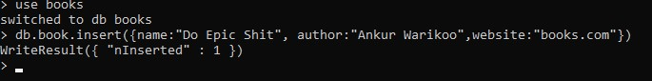

To check whether the document is successfully inserted, type the following command. It shows all the documents in the given collection.

Syntax: **db.collection_name.find()**



> db.book.find()

{ "_id" : ObjectId("6796832f786ec78947803f72"), "name" : "Do Epic Shit", "author" : "Ankur Warikoo", "website" : "books.com" }

To check whether the collection is created successfully, use the following command.

show collections

This command shows the list of all the collections in the currently selected database.

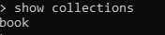

> show collections

book >

# Method 2: Creating collection with options before inserting the documents

We can also create collection before we actually insert data in it. This method provides you the options that you can set while creating a collection.

Syntax: db.createCollection(name, options) **name** is the collection name and **options** is an optional field that we can use to specify certain parameters such as size, max number of documents etc. in the collection.

First lets see how this command is used for creating collection without any parameters:

> db.createCollection("students")

{ "ok" : 1 }

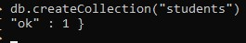

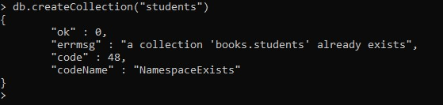

Lets see the options that we can provide while creating a collection: **capped**: type: boolean.

This parameter takes only true and false. This specifies a cap on the max entries a collection can have. Once the collection reaches that limit, it starts overwriting old entries.

The point to note here is that when you set the capped option to true you also have to specify the size parameter. **size**: type: number.

This specifies the max size of collection (capped collection) in bytes.

**max**: type: number.

This specifies the max number of documents a collection can hold. **autoIndexId**: type: boolean

The default value of this parameter is false. If you set it true then it automatically creates index field _id for each document. We will learn about index in the MongoDB indexing tutorial.

Lets see an example of capped collection:

>db.createCollection("teachers", { capped : true, size : 9232768} ) { "ok" : 1 }

>



This command will create a collection named “teachers” with the max size of 9232768 bytes. Once this collection reaches that limit it will start overwriting old entries.

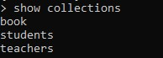

> show collections

book students teachers

# Drop collection in MongoDB

To drop a collection , first connect to the database in which you want to delete collection and then type the following command to delete the collection: db.collection_name.drop()

Note: Once you drop a collection all the documents and the indexes associated with them will also be dropped. To preserve the indexes we use remove() function that only removes the documents in the collection but doesn’t remove the collection itself and the indexes created on it.

# MongoDB drop collection Example

For example delete a collection names “teachers” in my database “books”. Write the following commands in the given sequence.

> use books switched to books > show collections book students teachers

> db.teachers.drop() true

> show collections

book students

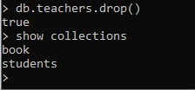

As you can see that the command db.teachers.drop() returned true which means that the collection is deleted successfully.

# MongoDB Insert Document

**Syntax to insert a document into the collection:** db.collection_name.insert()

Lets take an example to understand this .

# MongoDB Insert Document using insert() Example

Here we are inserting a document into the collection named “book”. The field “genre” in the example below is an array that holds the several key-value pairs.

You should see a successful write message like this:

WriteResult({"nInserted":1})

The insert() method creates the collection if it doesn’t exist but if the collection is present then it inserts the document into it

> db.book.insert({ name:"Spin the bottle", author:"Stephanie Alves", genre:[{name:"Romance", rating:5},{name:"Novel", rating:5}] }) WriteResult({ "nInserted" : 1 })



**Verification:**

You can also verify whether the document is successfully inserted by typing following command: db.collection_name.find()

In the above example, we inserted the document in the collection named “book” so the command should be:

> db.book.find()

{ "_id" : ObjectId("6796832f786ec78947803f72"), "name" : "Do Epic Shit", "author" : "Ankur

Warikoo", "website" : "books.com" }

{ "_id" : ObjectId("679685db786ec78947803f73"), "name" : "Spin the bottle", "author" :

"Stephani Alves", "genre" : [ { "type" : "Romance", "rating" : 5 }, { "type" : "Novel", "rating" : 5 } ] }

{ "_id" : ObjectId("6796867e786ec78947803f74"), "name" : "Spin the bottle", "author" :

"Stephanie Alves", "genre" : [ { "name" : "Romance", "rating" : 5 }, { "name" : "Novel", "rating" :

5 } ] }

>

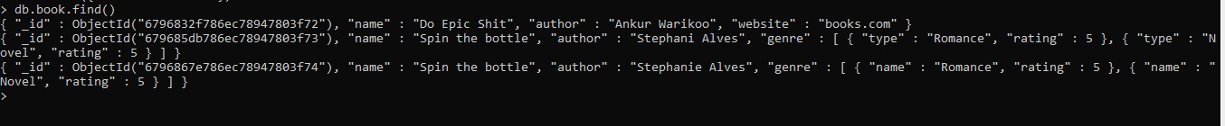

# MongoDB Example: Insert Multiple Documents in collection

To insert multiple documents in collection, we define an array of documents and later we use the insert() method on the array variable as shown in the example below. Here we are inserting three documents in the collection named “students”. This command will insert the data in “students” collection, if the collection is not present then it will create the collection and insert these documents.

> var beginners=

... [

... {

... "StudentId":101,

... "StudentName":"Anya",

... "age": 22

... },

... {"StudentId":102,

... "StudentName":"Navya",

... "age":23

... },

... {"StudentId":103,

... "StudentName":"Ravi",

... "age":24

... }

... ];

> db.students.insert(beginners);

BulkWriteResult({

"writeErrors" : [ ],

"writeConcernErrors" : [ ],

"nInserted" : 3,

"nUpserted" : 0,

"nMatched" : 0,

"nModified" : 0,

"nRemoved" : 0,

"upserted" : [ ]

})

>

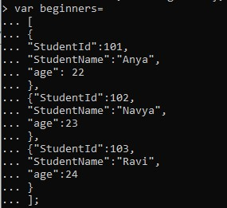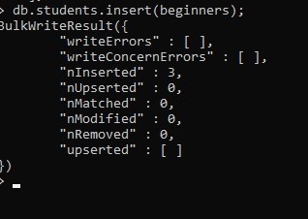

As you can see that it shows number 3 in front of **nInserted**. this means that the 3 documents have been inserted by this command.



> db.students.find()

{ "_id" : ObjectId("679687dd786ec78947803f75"), "StudentId" : 101, "StudentName" : "Anya", "age" : 22 }

{ "_id" : ObjectId("679687dd786ec78947803f76"), "StudentId" : 102, "StudentName" : "Navya", "age" : 23 }

{ "_id" : ObjectId("679687dd786ec78947803f77"), "StudentId" : 103, "StudentName" : "Ravi", "age" : 24 }

>

You can print the output data in a JSON format so that you can read it easily. To print the data in JSON format run the command **db.collection_name.find().forEach(printjson)**

So in our case the command would be this:

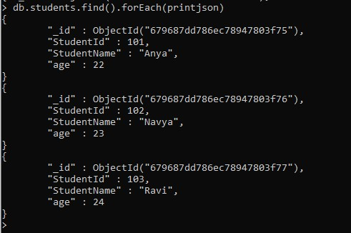

# MongoDB Query Document using find() method

## Querying all the documents in JSON format

Lets say we have a collection students in a database named books. To get all the documents we use this command: db.students.find()

However the output we get is not in any format and less-readable. To improve the readability, we can format the output in JSON format with this command: db.students.find().forEach(printjson);

OR simply use pretty() – It does the same thing.

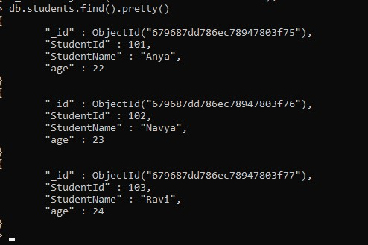

## Query Document based on the criteria

Instead of fetching all the documents from collection, we can fetch selected documents based on a criteria.

**Equality Criteria:**

For example: To fetch the data of “Navya” from students collection. The command for this should be:

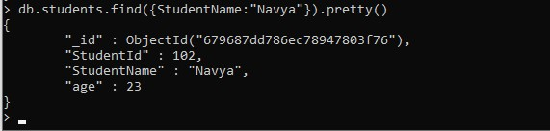

**Greater Than Criteria:** Syntax: db.collection_name.find({"field_name":{$gt:criteria_value}}).pretty()

For example: To fetch the details of students having age > 32 then the query should be:

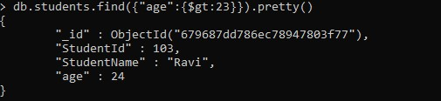

**Less than Criteria:** Syntax: db.collection_name.find({"field_name":{$lt:criteria_value}}).pretty()

Example: Find all the students having id less than 3000. The command for this criteria would be:

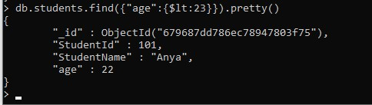

**Not Equals Criteria:** Syntax: db.collection_name.find({"field_name":{$ne:criteria_value}}).pretty()

Example: Find all the students where id is not equal to 102. The command for this criteria would be:

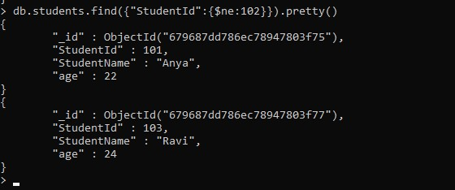

**Greater than equals Criteria:**

db.collection_name.find({"field_name":{$gte:criteria_value}}).pretty() **Less than equals Criteria:** db.collection_name.find({"field_name":{$lte:criteria_value}}).pretty()

The pretty() method that we have added at the end of all the commands is not mandatory. It is just used for formatting purposes.

# MongoDB – Update Document in a Collection

In MongoDB, we have two ways to update a document in a collection. 1) update() method 2) save() method. Although both the methods update an existing document, they are being used in different scenarios. The update() method is used when we need to update the values of an existing document while save() method is used to replace the existing document with the document that has been passed in it.

To update a document in MongoDB, we provide a criteria in command and the document that matches that criteria is updated.

## Updating Document using update() method

**Syntax:**

db.collection_name.update(criteria,update_data) **Example:**

For example: Use a collection named “got” in the database “books”. The documents inside “got” are:

> use beginnersbookdb switched to dbbeginnersbookdb

> show collections beginnersbook students students11

>db.createCollection("got")

{ "ok" : 1 }

>

>varabc = [

... {

... "_id" :ObjectId("59bd2e73ce524b733f14dd65"),

... "name" : "Jon Snow",

... "age" : 32

... },

... {

... "_id" :ObjectId("59bd2e8bce524b733f14dd66"),

... "name" : "KhalDrogo",

... "age" : 36

... },

... {

... "_id" :ObjectId("59bd2e9fce524b733f14dd67"),

... "name" : "Sansa Stark",

... "age" : 20

... },

... {

... "_id" :ObjectId("59bd2ec5ce524b733f14dd68"),

... "name" : "Lord Varys",

... "age" : 42

... },

... ];

>db.got.insert(abc);

BulkWriteResult({

"writeErrors" : [ ],

"writeConcernErrors" : [ ],

"nInserted" : 4,

"nUpserted" : 0,

"nMatched" : 0,

"nModified" : 0,

"nRemoved" : 0,

"upserted" : [ ] })

>db.got.find().pretty()

{

"_id" :ObjectId("59bd2e73ce524b733f14dd65"),

"name" : "Jon Snow",

"age" : 32

}

{

"_id" :ObjectId("59bd2e8bce524b733f14dd66"),

"name" : "KhalDrogo",

"age" : 36

}

{

"_id" :ObjectId("59bd2e9fce524b733f14dd67"), "name" : "Sansa Stark",

"age" : 20

}

{

"_id" :ObjectId("59bd2ec5ce524b733f14dd68"),

"name" : "Lord Varys",

"age" : 42

}

>

To update the name of Jon Snow with the name “Kit Harington”. The command for this would be:

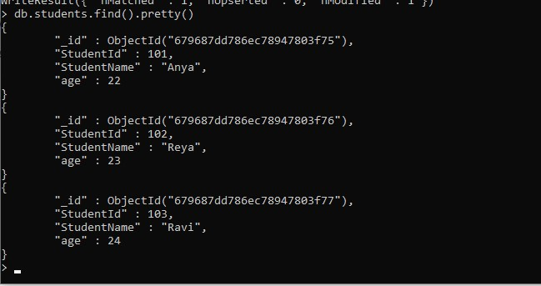

By default the update method updates a single document. In the above example we had only one document matching with the criteria, however if there were more then also only one document would have been updated. To enable update() method to update multiple documents you have to set “multi” parameter of this method to true as shown below.

**To update multiple documents with the update() method:**

db.got.update({"name":"Jon Snow"},

{$set:{"name":"Kit Harington"}},{multi:true})

## Updating Document using save() method

**Syntax:**

db.collection_name.save({_id:ObjectId(),new_document})

Lets take the same example that we have seen above. Now we want to update the name of “Reya” to “Rhea”. To work with save() method you should know the unique _id field of that document.

A very important **point to note** is that when you do not provide the **_id** field while using save()

method, it calls insert() method and the passed document is inserted into the collection as a new document

To get the _id of a document, you can either type this command: db.students.find().pretty()

Here got is a collection name. This method of finding unique _id is only useful when you have few documents, otherwise scrolling and searching for that _id in huge number of documents is tedious.

If you have huge number of documents then, to get the _id of a particular document use the criteria in find() method. For example: To get the _id of the document that we want to update using save() method, type this command:

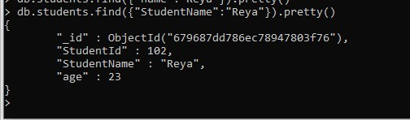



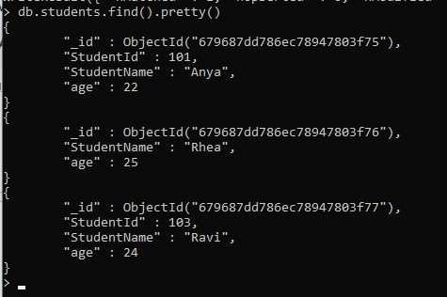

# MongoDB Delete Document from a Collection

In this tutorial we will learn how to delete documents from a collection. The remove() method is used for removing the documents from a collection in MongoDB.

**Syntax of remove() method:**

db.collection_name.remove(delete_criteria)

## Delete Document using remove() method

Lets use a collection students in my MongoDB database named books. The documents in students collection are:



To remove the student from this collection who has a student id equal to 3333. Write a command using remove() method like this:

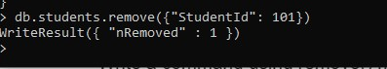

To verify whether the document is actually deleted.

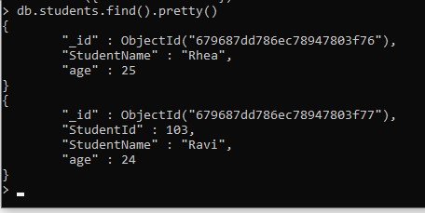

It will list all the documents of students collection.

> use beginnersbookdb switched to dbbeginnersbookdb

>db.students.find().pretty()

{

"_id" :ObjectId("5c281c90c23e08d1515fd9cc"),

"StudentId" : 1001,

"StudentName" : "Steve",

"age" : 30

}

{

"_id" :ObjectId("5c281c90c23e08d1515fd9cd"),

"StudentId" : 1002,

"StudentName" : "Negan",

"age" : 42

}

{

"_id" :ObjectId("5c281c90c23e08d1515fd9ce"),

"StudentId" : 3333,

"StudentName" : "Rick",

"age" : 35

}

{

"_id" :ObjectId("5c2d38934fa204bd77e7fc1d"),

"StudentId" : 1001,

"StudentName" : "Steve",

"age" : 30

}

{

"_id" :ObjectId("5c2d38934fa204bd77e7fc1e"),

"StudentId" : 1002,

"StudentName" : "Negan",

"age" : 42

}

{

"_id" :ObjectId("5c2d38934fa204bd77e7fc1f"),

"StudentId" : 3333,

"StudentName" : "Rick",

"age" : 35

}

>db.students.remove({"StudentId": 3333})

WriteResult({ "nRemoved" : 2 })

>db.students.find().pretty()

{

"_id" :ObjectId("5c281c90c23e08d1515fd9cc"),

"StudentId" : 1001,

"StudentName" : "Steve",

"age" : 30

}

{

"_id" :ObjectId("5c281c90c23e08d1515fd9cd"),

"StudentId" : 1002,

"StudentName" : "Negan",

"age" : 42

}

{

"_id" :ObjectId("5c2d38934fa204bd77e7fc1d"),

"StudentId" : 1001,

"StudentName" : "Steve",

"age" : 30

}

{

"_id" :ObjectId("5c2d38934fa204bd77e7fc1e"),

"StudentId" : 1002,

"StudentName" : "Negan",

"age" : 42

}

>

**How to remove only one document matching your criteria?**

When there are more than one documents present in collection that matches the criteria then all those documents will be deleted if you run the remove command. However there is a way to limit the deletion to only one document so that even if there are more documents matching the deletion criteria, only one document will be deleted.

db.collection_name.remove(delete_criteria,justOne)

Here justOne is a Boolean parameter that takes only 1 and 0, if you give 1 then it will limit the the document deletion to only 1 document. This is an optional parameters as we have seen above that we have used the remove() method without using this parameter.

Example:

db.walkingdead.remove({"age": 32}, 1)

## Remove all Documents

If you want to remove all the documents from a collection but does not want to remove the collection itself then you can use remove() method like this:

db.collection_name.remove({})

# MongoDB Projection

This is used when we want to get the selected fields of the documents rather than all fields.

For example, we have a collection where we have stored documents that have the fields: StudentId, StudentName, age but we want to see only the StudentId of all the students then in that case we can use projection to get only the StudentId.

**Syntax:**

db.collection_name.find({},{field_key:1or0})

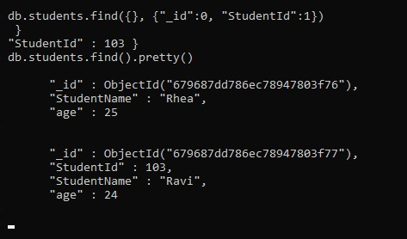

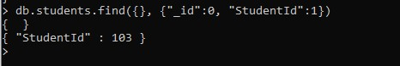

Value 1 means show that field and 0 means do not show that field. When we set a field to 1 in Projection other fields are automatically set to 0, except _id, so to avoid the _id we need to specifically set it to 0 in projection. The vice versa is also true when we set few fields to 0, other fields set to 1 automatically.

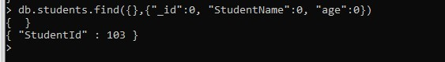

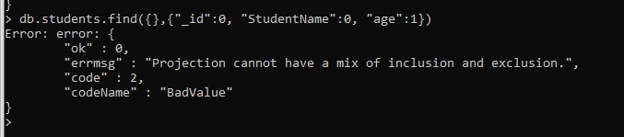

This is because we have set student_name to 0 and other field student_age to 1. We can’t mix these. You either set those fields that you don’t want to display to 0 or set the fields to 1 that you want to display.

# MongoDB – limit( ) and skip( ) method

## The limit() method in MongoDB

This method limits the number of documents returned in response to a particular query.

Syntax:

db.collection_name.find().limit(number_of_documents) db.studentdata.find({student_id : {$gt:2002}}).pretty() db.studentdata.find({student_id : {$gt:2002}}).limit(1).pretty()

## MongoDB Skip() Method

The skip() method is used for skipping the given number of documents in the Query result.

To understand the use of skip() method, lets take the same example that we have seen above. In the above example we can see that by using limit(1) we managed to get only one document, which is the first document that matched the given criteria. What if you do not want the first document matching your criteria.

For example we have two documents that have student_id value greater than 2002 but when we limited the result to 1 by using limit(1), we got the first document, in order to get the second document matching this criteria we can use skip(1) here which will skip the first document.

db.studentdata.find({student_id : {$gt:2002}}).limit(1).skip(1).pretty()

# MongoDB sort() method

## Sorting Documents using sort() method

Using sort() method, you can sort the documents in ascending or descending order based on a particular field of document.

**Syntax of sort() method:** db.collecttion_name.find().sort({field_key:1or-1})

1 is for ascending order and -1 is for descending order. The default value is 1.

**For example:** collection studentdata contains following documents:

>db.studentdata.find().pretty()

{

"_id" :ObjectId("59bf63380be1d7770c3982af"),

"student_name" :"Steve",

"student_id" :2002,

"student_age" :22

}

{

"_id" :ObjectId("59bf63500be1d7770c3982b0"),

"student_name" :"Carol",

"student_id" :2003,

"student_age" :22

}

{

"_id" :ObjectId("59bf63650be1d7770c3982b1"),

"student_name" :"Tim",

"student_id" :2004,

"student_age" :23

}

Let’s display the student_id of all the documents in **descending order**:

>db.studentdata.find({}, {"student_id": 1, _id:0}).sort({"student_id": -1})

{ "student_id" : 2004 }

{ "student_id" : 2003 }

{ "student_id" : 2002 }

To display the student_id field of all the students in **ascending order**:

**Default:** The default is ascending order so if any value is not provided in the sort() method then it will sort the records in ascending order as shown below:

>

db.studentdata.find({},

{

"student_id"

:

1

, _id:

0

})

.sort

({

"student_id"

:

1

})

{

"student_id"

:

2002

}

{

"student_id"

:

2003

}

{

"student_id"

:

2004

}

>db.studentdata.find({}, {"student_id": 1, _id:0}).sort({})

{ "student_id" : 2002 }

{ "student_id" : 2003 }

{ "student_id" : 2004 }

**You can also sort the documents based on the field that you don’t want to display:** For example, you can sort the documents based on student_id and display the student_age and student_name fields.

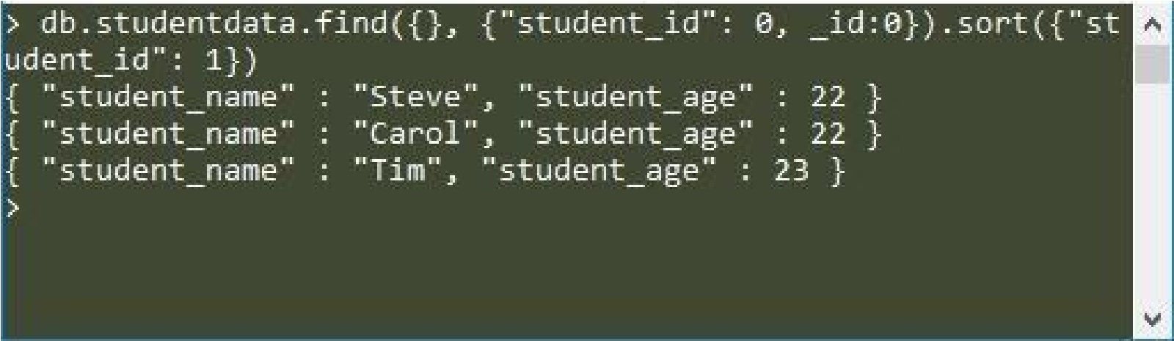**MongoDB**

### Indexing Tutorial with

**Example**

An **index** in MongoDB is a special data structure that holds the data of few fields of documents on which the index is created. Indexes improve the speed of search operations in database because instead of searching the whole document, the search is performed on the indexes that hold only few fields. On the other hand, having too many indexes can hamper the performance of insert, update and delete operations because of the additional write and additional data space used by indexes.

### How to create index in MongoDB

db.collection_name.createIndex({field_name:1or-1})

The value 1 is for ascending order and -1 is for descending order.

For example, use collection studentdata. The documents inside this collection have following fields: student_name, student_id and student_age

Let’s create the index on student_name field in ascending order:

db.studentdata.createIndex({student_name:

1

})

**Output:**

We have created the index on student_name which means when someone searches the document based on the student_name, the search will be faster because the index will be used for this search. So this is important to create the index on the field that will be frequently searched in a collection.

{

"createdCollectionAutomatically"

:

false

,

"numIndexesBefore"

:

1

,

"numIndexesAfter"

:

2

,

"ok"

:

1

}

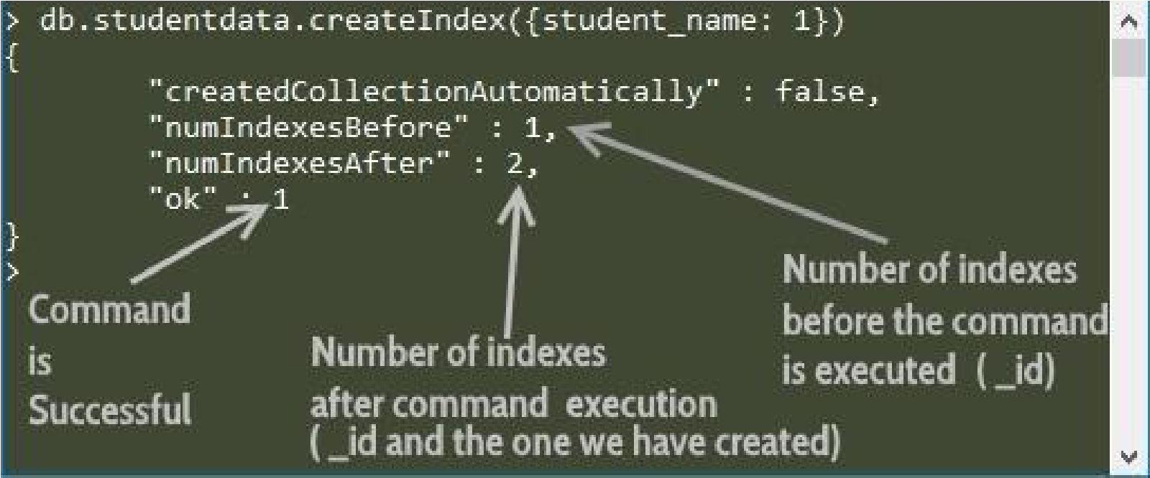

## MongoDB – Finding the indexes in a collection

We can use getIndexes() method to find all the indexes created on a collection.

The syntax for this method is:

db.collection_name.getIndexes()

So to get the indexes of

studentdata

collection, the command would be:

>

db.studentdata.getIndexes

()

[

{

"v"

:

2

,

"key"

:{

"_id"

:

1

}

,

"name"

:

"_id_"

,

"ns"

:

"test.studentdata"

}

,

{

"v"

:

2

,

"key"

:{

"student_name"

:

1

}

,

"name"

:

"student_name_1"

,

"ns"

:

"test.studentdata"

}

]

The output shows that we have two indexes in this collection. The default index

created on _id and the index that we have created on student_name field.

## MongoDB – Drop indexes in a collection

You can either drop a particular index or all the indexes.

**Dropping a specific index:**

|  |  |  |
| --- | --- | --- |
| db.collection_name.dropIndex({index_name:1}) | | |
| Lets drop the index that we have created on collection studentdata. The command for this: db.studentdata.dropIndex({student_name:1}) | student_name | field in the |
|  |

For this purpose the dropIndex() method is used. nIndexesWas: It shows how many indexes were there before this command got executed ok: 1: This means the command is executed successfully.

**Dropping all the indexes:**

To drop all the indexes of a collection, we use dropIndexes() method.

Syntax of dropIndexs() method:

db.collection_name.dropIndexes()

Lets say we want to drop all the indexes of

studentdata

collection.

db.studentdata.dropIndexes()

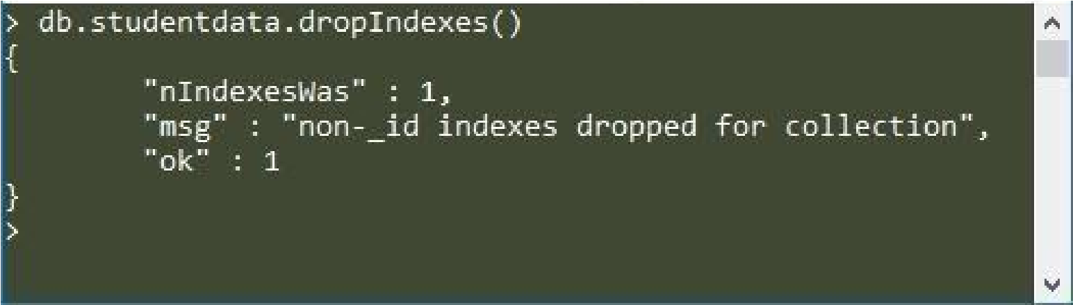

The message “non-_id indexes dropped for collection” indicates that the default

index _id will still remain and cannot be dropped. This means that using this

method we can only drop indexes that we have created, we can’t drop the default

index created on _id field.

**Practical 10**

**AIM : Time Series**

Time Series Forecasting with Python

In data science, predicting future values is a common task. To do that, we can implement time series forecasting models with Python.

Time series forecasting models are designed to predict future values of a time series dataset by analyzing historical data. These models include classical forecasting methods such as ARIMA and Exponential Smoothing (ETS), as well as machine learning approaches that utilize supervised learning algorithms to automatically detect patterns within the data.

Traditional forecasting models, like ARIMA and Exponential Smoothing (ETS), use statistical techniques to analyze historical data and predict future values in time series datasets. These models effectively capture components such as trend, seasonality, and autoregression for accurate forecasting.

Time Series Characteristics

**Stationarity**: A time series is considered stationary when its data points exhibit independence from time. Therefore, time series containing [trends or seasonal patterns](https://www.blog.trainindata.com/seasonal-time-series-forecasting/) are non-stationary.

**Differencing**: Differencing involves calculating the differences between consecutive points in a non-stationary time series to transform it into a stationary one.

**Classical Forecasting Models**

Here’s a simple explanation of popular forecasting models used for time series data:

* **Autoregressive Models (AR)**

AR models predict future values based on a combination of past values. For example, an AR(2) model uses the last two values to make predictions.

* **Moving Average Models (MA)**

MA models use past errors (differences between actual and predicted

values) to forecast. A MA(2) model uses errors from the last two data points.

* **Autoregressive Moving Average (ARMA)**

ARMA combines both AR (past values) and MA (past errors) to make predictions.

* **Autoregressive Integrated Moving Average (ARIMA)**

ARIMA adds a step to make the data stationary (removing trends or seasonality) before using AR and MA components. The “I” stands for

"integration," which is the process of differencing the data to stabilize it.

ARIMA can also handle seasonality and external factors if needed. **Implementing statistical forecasting models with Python**

Code:

try:

import numpy as np import pandas as pd import matplotlib.pyplot as plt from statsmodels.tsa.statespace.sarimax import SARIMAX from statsmodels.tsa.arima.model import ARIMA

# Load the data and ensure the index has a proper frequency

url =

"https://raw.githubusercontent.com/facebook/prophet/main/examples/exam ple_air_passengers.csv" data = pd.read_csv(url, header=0, parse_dates=[0], index_col=0) data.index.freq = 'MS' # Setting the frequency to Monthly Start

# Split into training and test datasets train = data.iloc[:-12] test = data.iloc[-12:]

# Fit ARIMA model arima_model = ARIMA(train, order=(5, 1, 0)) arima_result = arima_model.fit()

# Forecast the next 12 months arima_forecast = arima_result.forecast(steps=12)

# Fit SARIMAX model

sarimax_model = SARIMAX(train, order=(1, 1, 1), seasonal_order=(1, 1, 1,

12)) sarimax_result = sarimax_model.fit() sarimax_forecast = sarimax_result.forecast(steps=12)

# Plot the results plt.figure(figsize=(10, 5)) plt.plot(train, label='Train') plt.plot(test, label='Test', color='orange')

plt.plot(test.index, arima_forecast, label='ARIMA Forecast', color='green', linestyle='--')

plt.plot(test.index, sarimax_forecast, label='SARIMAX Forecast', color='blue', linestyle='--') plt.legend() plt.title('ARIMA vs SARIMAX Forecasting') plt.xlabel('Date') plt.ylabel('Passengers') plt.grid()

plt.show()

except Exception as e: print(f"Error: {e}") Output:

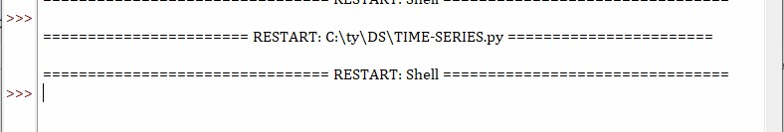

Use CMD

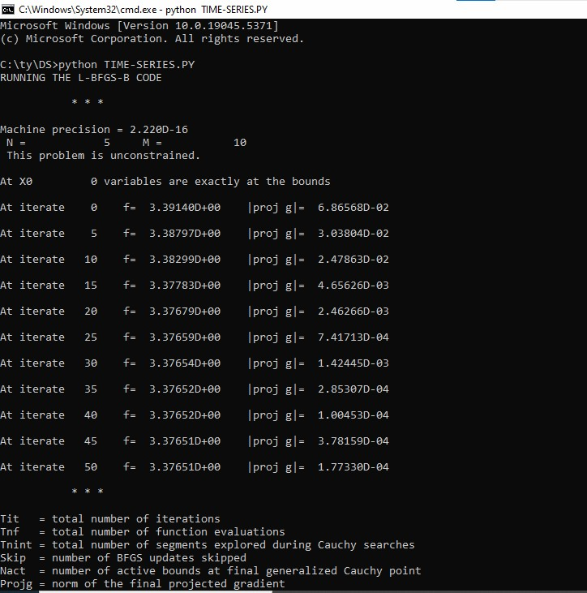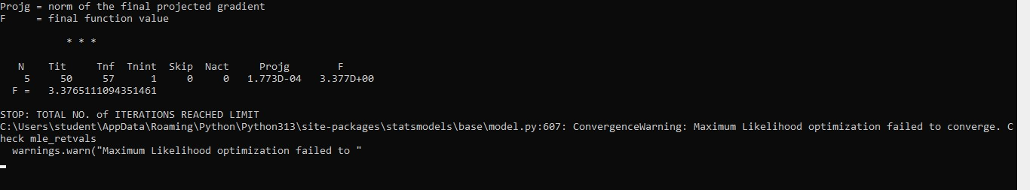

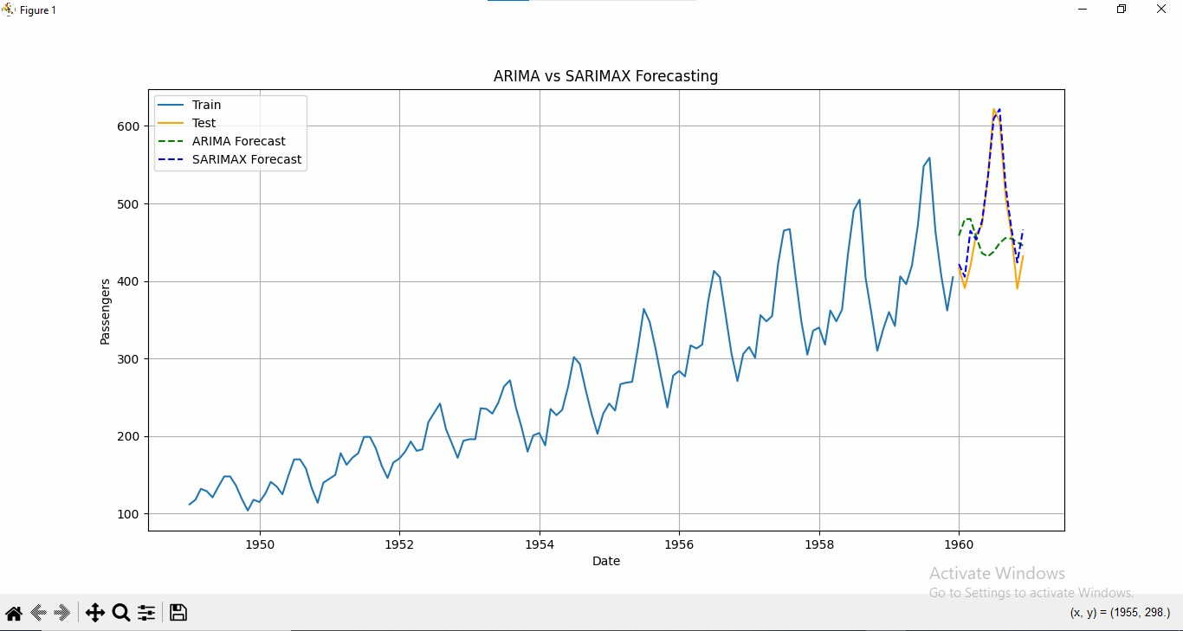

1. **ARIMA Forecast**:

The ARIMA model is trained with a (5, 1, 0) configuration on the training data (all data except the last 12 months).

It predicts the passenger numbers for the next 12 months.

The forecast is plotted against the test dataset (last 12 months).

1. **SARIMAX Forecast**:

The SARIMAX model uses seasonal parameters (1, 1, 1, 12) to capture seasonality.

It also forecasts the passenger numbers for the same 12-month period as ARIMA.

This forecast is plotted alongside the ARIMA results and actual test data.

1. **Visualization**:

The plot includes:

The training data (blue line).

The actual test data (orange line).

The ARIMA forecast (green dashed line).

The SARIMAX forecast (blue dashed line). This comparison allows visual evaluation of the models' performance.

**Expected Insights:**

* **Model Performance**:

The plots should show how closely the forecasts align with the actual test data.

SARIMAX is expected to perform better if the data has significant seasonality due to its seasonal components.

* **Trend Prediction**:

Both models should capture the increasing trend in air passenger traffic.

Differences in predictions may reveal the strengths of each model in capturing patterns.

**\*\*\*\*\*\***